
Tertiary Infotech Academy Pte Ltd
UEN: 201200696W
LEARNER GUIDE
For
Claude AI Masterclass
Classic Projects Edition
Course Code: C1382
Conducted by
Tertiary Infotech Academy Pte Ltd
UEN: 201200696W
Version 6.0 · 28 October 2026

DOCUMENT VERSION CONTROL RECORD
Version Number | Effective Date of Release | Summary of Included Changes | Author
1.0 | 15 September 2026 | Initial release. | Dr. Alfred Ang
2.0 | 15 September 2026 | Finance task automation scenarios. | Dr. Alfred Ang
2.1 | 16 September 2026 | Eight finance labs with mock data and skills. | Dr. Alfred Ang
3.0 | 17 September 2026 | Rebuilt on the Claude Style design with three topics and six labs on one fictitious finance firm; prompts added to the slides, Learner Guide and labs. | Dr. Alfred Ang
3.1 | 17 September 2026 | Added an invoice-processing first lab, the context window section, the skill lifecycle and the two About the Trainer slides. | Dr. Alfred Ang
3.2 | 18 September 2026 | Restructured to ten labs: connectors, a built-in skill board deck, two learner-written skills, a Claude Project and a plugin. | Dr. Alfred Ang
4.0 | 18 September 2026 | First stable release of the ten-lab finance course. | Dr. Alfred Ang
4.1 | 18 September 2026 | Lab 4: recovery step for the Google Drive connector's "insufficient scope" error. | Dr. Alfred Ang
4.2 | 18 September 2026 | Moved the Skills vs. Plugins diagram to sit immediately before the plugin lab. | Dr. Alfred Ang
5.0 | 27 October 2026 | Renamed Claude AI Masterclass and rebuilt for marketing teams on the redesigned Claude Projects: one fictitious brand launch (Lumo Kopi Co.) run in a single project across ten labs, with a lead agent and parallel threads, Live Artefacts, Drive and Gmail, Slides and Docs, skills, plugins and mods, social posts, a launch video and scheduled tasks. Lab folders now hold only the prompt PDF and data; full instructions are in the Learner Guide and every prompt is on a copy-ready prompts page. Trainer profile adds the Claude Certified Associate certification. | Dr. Alfred Ang
5.1 | 27 October 2026 | Issued in two editions from one source. The Classic Projects Edition teaches Projects as most accounts show them today — Instructions, Context, Folder and Scheduled panels, with parallel tasks started by the learner and a project memory file — and is the edition distributed to learners. The Threads Edition keeps the redesigned Projects with a lead agent and parallel threads. The prompts page adds a lab index and links the two editions; the AI history slide follows the Agentic AI Applications with Claude Code deck. | Dr. Alfred Ang
5.2 | 27 October 2026 | Topic 1 adds Project vs Session, a diagram of how sessions sit in a project (Classic) or how project, session, thread and agent relate (Threads), A Project Answers Four Questions (Instructions HOW, Context WHAT, Folder WHERE, Scheduled WHEN), Instructions vs Context and the project-room analogy; the pricing slide is updated (Free, Pro, Max, Team and Enterprise) and a Claude models slide added (Haiku, Sonnet, Opus, Fable). Every lab gains an In the project panel. Lab 7 builds a Next Lumo post mod; Lab 8 now schedules the daily post; Lab 10 schedules the weekly report. Timetable rebalanced (Lab 7 25 min, Lab 8 40 min, Lab 10 20 min). Glossary adds Context, Instructions and Session. Seventeen annotated screenshots from the class delivery added to the deck and LG: plan and usage, model and effort menus, permission mode, the project page and + menu, the Gmail connector, installing a skill, and the Lab 3, Lab 4 and Lab 8 outputs. | Dr. Alfred Ang
6.0 | 28 October 2026 | Rebuilt Topic 2 around learner feedback asking for more practical depth on Claude's tools and skills, with direct Claude examples in place of analogies. New slides and LG sections: tools vs skills, Claude's built-in tools, how Claude calls a tool, the Lab 4 tool-call trace, tool permissions, six everyday connector jobs, tool troubleshooting, data analysis with the code tool, the kinds of skill, the lumo-brand-voice SKILL.md, good and bad descriptions, a gallery of workplace skills and skill troubleshooting. Lab 4 adds Drive search and Gmail draft use cases and has Claude list its tool calls; Lab 5 opens with a survey analysis saved to Excel; Lab 6 uses the skill on supplied customer messages, then updates and retests it; Lab 7 opens a plugin's skills. New shared sample data: lumo-customer-messages.txt and the survey in Lab 5. The project-room analogy is replaced by where each part lives in the app. Timetable rebalanced: Topic 2 gains 30 minutes (Topic 1 theory 30 min, Lab 2 35, Topic 2 tools 40 and skills 15, Labs 4-6 35 each; Lab 8 35, Lab 9 25, recap 10). | Dr. Alfred Ang

TABLE OF CONTENTS
Introduction 6
Course Learning Outcomes 6
Before You Start — Preparation 7
Working in a Claude Project 13
How a project is organised 13
The parts of a project 16
Creating the project 17
Writing project instructions 18
Adding context and using the folder 18
Keeping a memory file 19
Scheduling tasks 19
Coming soon: the new Projects 20
Topic 01 — Claude Projects and Market Research 21
The Claude family 21
Lab 1 — Set Up the Lumo Launch Project 21
Market research in parallel tasks 25
Lab 2 — Run Market Research in Parallel Tasks 25
Live Artefacts 29
Lab 3 — Build the Market Insights Live Artefact 29
Topic 02 — Connectors, Skills and Plugins 34
Tools and skills 34
Connectors and the context window 36
Lab 4 — Connect Google Drive and Gmail 39
Analysing data with Claude 45
Slides, Docs and built-in skills 45
Lab 5 — Analyse the Survey, Then Build the Deck and Brief 46
Agent Skills 50
Lab 6 — Capture the Brand Voice as an Agent Skill 53
Skills, plugins and mods 57
Lab 7 — Add the Marketing Plugin and a Mod 57
Topic 03 — Content Production and Scheduled Work 61
Social content for four platforms 61
Lab 8 — Create and Schedule Two Weeks of Social Posts 62
The video pipeline 66
Lab 9 — Produce a 15-Second Launch Video 66
Scheduled tasks 69
Lab 10 — Schedule the Weekly Report and Review the Project 69
Wrap-Up 73
Glossary 74

Introduction
Claude is no longer only a chat window. In Cowork, a Claude Project gives one body of work its own instructions, reference files and working folder, so every task you start already knows the brand and the rules. This course teaches that way of working through one continuous marketing scenario: you are the marketing team at Lumo Kopi Co., launching a new canned cold-brew kopi. Over ten labs, all inside one project, you research the market in parallel tasks, build a Live Artefact dashboard, connect Google Drive and Gmail, produce a launch deck and campaign brief, capture the brand voice as a skill, add a marketing plugin, create two weeks of social posts and a launch video, and schedule the routine work so it runs on its own.
The scenario — The Lumo Cold Kopi launch
The situation: It is late October 2026. Lumo Kopi Co. launches Lumo Cold Kopi, its first ready-to-drink canned kopi, in Singapore on 1 December — six weeks away — and in Kuala Lumpur in January. The marketing team is small, the budget is S$60,000, and nothing has been produced yet: no research, no deck, no posts, no video.
Your role: You are the Lumo marketing team. Instead of juggling a dozen separate chats, you run the whole launch from one Claude Project in Cowork: its instructions, brand kit and working folder are set up once, and every task you start inside it already knows the brand.
Your mission: By the end of the day the project holds everything the launch needs — verified market research, a dashboard, a deck and brief, a brand-voice skill, two weeks of social posts, a launch video — and scheduled tasks that keep it moving while you are away.
Lumo Kopi Co. is a fictitious Singapore coffee brand about to launch Lumo Cold Kopi — a ready-to-drink oat-milk kopi cold brew in a 240 ml can — in Singapore on 1 December 2026 and Kuala Lumpur in January 2027. You are its marketing team. All brands, figures, survey answers and documents in this course are synthetic and used for training only.
This guide carries the full instructions for all 10 labs. Each lab folder in the course repository holds only the lab's prompt PDF and, where the lab needs it, a data folder; the goal, every prompt, the step-by-step instructions and the check step for each lab are here.

Course Learning Outcomes
On completion of this course, you will be able to:
- LO1: Set up a Claude Project in Cowork with instructions, context, a working folder and a project memory file.
- LO2: Run multi-subject market research as parallel tasks in one project and consolidate it into one verified research brief.
- LO3: Build, refine, save and download a Live Artefact dashboard from supplied research data.
- LO4: Connect Google Drive and Gmail and use their tools to reconcile, search, save and draft, sending only what you approve.
- LO5: Analyse survey data with Claude's code tool and Excel, and produce a launch deck and campaign brief with Slides and Docs using built-in skills.
- LO6: Capture a brand voice as an Agent Skill with /skill-creator, use and update it on workplace messages, and install and use a marketing plugin.
- LO7: Create a two-week, multi-platform set of social media posts using the brand-voice skill.
- LO8: Produce a short vertical launch video from a script, storyboard and supplied brand assets.
- LO9: Schedule recurring project tasks and keep the project's instructions, context and memory file current, with a human approval step.

Before You Start — Preparation
What you need
- A laptop (Mac or Windows) with the Claude desktop app installed from claude.ai/download.
- A Claude account on a paid plan (Pro or Max) — Projects, Cowork and Live Artefacts are paid-plan features.
- A Google account with Google Drive and Gmail, used for the connector labs.
- The course labs downloaded from https://github.com/tertiarycourses/C1382-Claude-AI-Masterclass — each lab folder holds a prompt PDF and, where needed, a data folder.
- The prompts page open in a browser, so you can copy each prompt with one click: https://tertiarycourses.github.io/C1382-Claude-AI-Masterclass/prompts/
Claude plans
Free lets you try Claude; Cowork, scheduled tasks and full Projects need Pro or Max.
Plan | Price and what it adds
Free | $0. Chat, Slides, Docs, connectors and skills, up to five projects. Sonnet and Haiku.
Pro | $17/mo billed annually · $20 monthly. Cowork, Projects, scheduled tasks and Opus.
Max | From $100/mo — 5× or 20× Pro's usage, priority at busy times, $100–$200/mo API credits.
Team · Enterprise | Team $20/seat annual ($25 monthly), premium seats $100. Enterprise $20/seat + usage.

Usage resets every five hours, with weekly limits on paid plans. US$ prices as of 27 October 2026 — verify at claude.com/pricing.
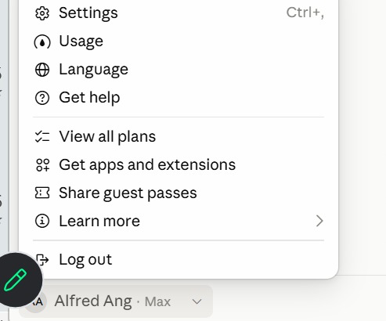
Figure 1 — Check Your Plan and Usage. Click your name at the bottom of the sidebar — the plan shows beside it (here, Max).
1. Usage — How much of your five-hour and weekly limits you have used.
2. View all plans — Compare Free, Pro, Max, Team and Enterprise, and upgrade.
3. Settings — Your profile, connectors and capabilities. Shortcut: Ctrl + comma.
Claude models
Four families, smallest to most capable; all read up to 1M tokens. API prices are US$ per million tokens, input · output.
Model | What it is | Use it for | API price | On plans
Haiku 5.5 | Fastest, most cost-efficient | Quick, high-volume jobs: tagging, short replies | $0.10 / $0.50 | All plans
Sonnet 5.5 | High performance for coding and agents | Everyday drafting, research and analysis | $2 / $10 | All plans
Opus 5.5 | Daily driver for agentic and enterprise work | Multi-step projects, parallel work, careful reviews | $4 / $20 | Pro and above
Fable 5.1 | Most capable, for long-running agents | The hardest, longest jobs | $10 / $50 | Max; Pro via usage credits

Pick the model from the model menu. Bigger models think harder and use more of your plan — save Fable for the jobs that need it.
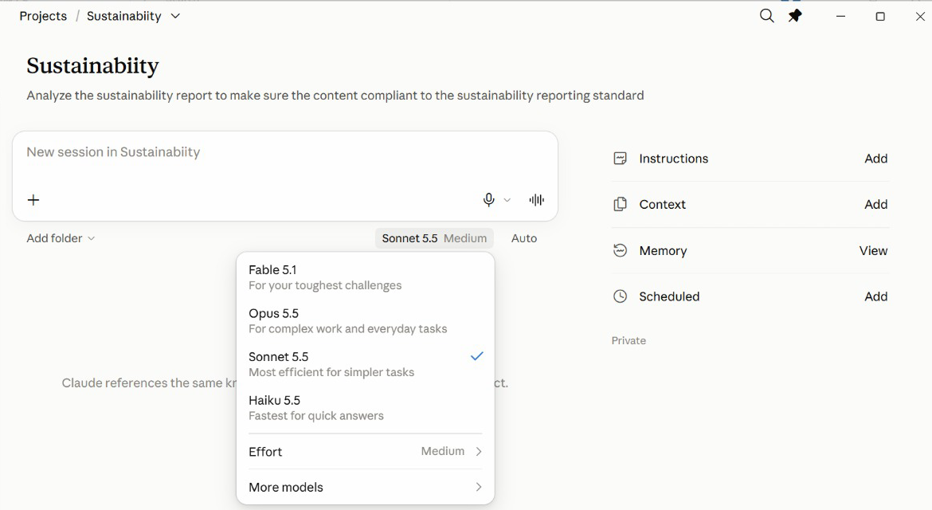
Figure 2 — Pick a Model in the App. The model menu sits under the message box of every new session.
1. Fable 5.1 — For your toughest challenges — uses the most of your plan.
2. Opus 5.5 — Complex work and everyday tasks.
3. Sonnet 5.5 — Efficient for most jobs — a sensible default.
4. Haiku 5.5 — Fastest, for quick answers.
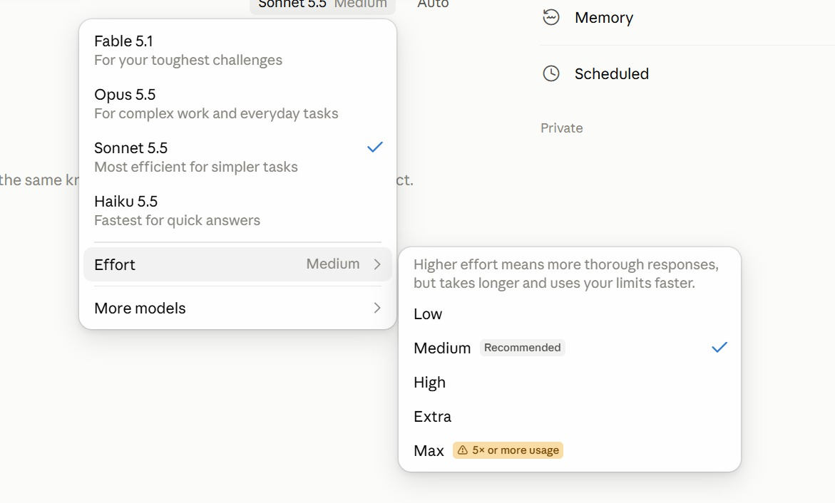
Figure 3 — Effort: How Hard Claude Thinks. Model menu → Effort. Medium is recommended for most work.
1. Low · Medium — Quick, everyday work. Medium is the recommended default.
2. High · Extra — Harder problems: more thorough, but slower and uses your limits faster.
3. Max — Five times or more the usage — save it for the hardest job.
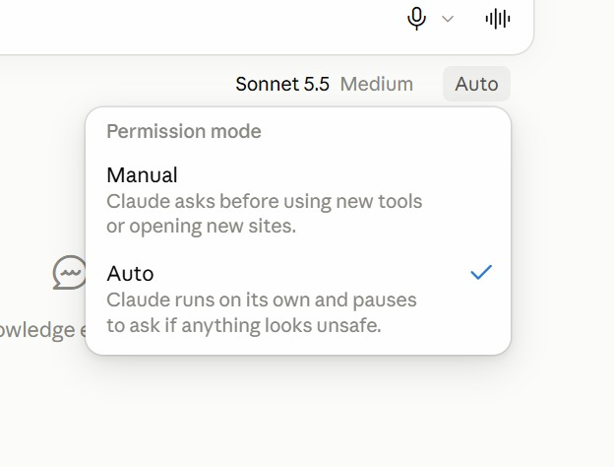
Figure 4 — Permission Mode: Manual or Auto. The menu beside the model sets how freely Claude acts in a session.
1. Manual — Claude asks before it uses a new tool or opens a new site.
2. Auto — Claude runs on its own and pauses to ask only if something looks unsafe.
3. Which to use — Manual while you learn a new connector; Auto once you trust the job.
Verify your setup
Open the Claude desktop app, sign in, switch to Cowork and open Projects. If you can start a new project and see its Instructions, Context, Folder and Scheduled panels, your setup is ready. (If your Projects page instead offers a Goal and talks about a lead agent and threads, your account has the new Projects — use the Threads edition of the labs.)
Course links
Resource | Address
Course repository (lab files) | https://github.com/tertiarycourses/C1382-Claude-AI-Masterclass
Copy-ready prompts page | https://tertiarycourses.github.io/C1382-Claude-AI-Masterclass/prompts/

Conventions used in every lab
- Prompts shown in a bordered box are copied into Claude exactly as they are — or copy them from the prompts page.
- Placeholders such as <YOUR EMAIL> are replaced with your own values.
- All Lumo Kopi data is synthetic; use only the supplied mock data.
- Every lab ends with a check step — confirm the output before moving on.
Rules for every lab
- Work from mock data — Use the supplied synthetic Lumo data — never real customer records in training.
- Scope the connector — Give Claude one Drive folder for the task, not your entire Drive.
- Check every figure — Read the artefact's and the brief's numbers back against the source file.
- Approve before sending — Read each drafted email and post in full; approve it only when the facts match.
- Use a test recipient — Send class exercises to yourself, never to a real customer.
- Draft-only schedules — A scheduled task runs unattended — let it draft and email you, never publish.
Note: Use only the supplied mock data and your own test accounts. Never put real customer, personal or confidential data into a training exercise, and send lab emails to yourself rather than to a real recipient.

Working in a Claude Project
Every lab in this course runs inside one Claude Project — Lumo Cold Kopi Launch — which you create in Lab 1. This chapter explains how a project works and how to set up each of its parts. Come back to it whenever a lab asks you to change the goal, instructions, context, memory or a scheduled task.

How a project is organised
A folder-backed project with four panels. Every task you start in the project reads its instructions, context and folder. Start several at once and they run in parallel — one task per subject.
- Instructions — Rules every task follows
- Context — Files Claude reads
- Folder — Where Claude works
- Scheduled — Tasks on a timetable
- Your tasks — Run one or several at once
- Memory file — Decisions kept in the folder
How this changes the way you work:
One-off chats | A Claude Project in Cowork
A chat for copy, one for visuals, one for competitors. | Instructions written once, followed by every task.
Re-attach the brand kit every time. | The brand kit added once as context.
Restate the rules from memory each time. | A real working folder Claude reads and writes.
Outputs scattered across conversations. | Scheduled tasks that belong to the project.
Nothing for a colleague to pick up. | Hand the folder to a colleague and they are ready.

Projects and sessions
The project keeps the setup; a session does one piece of work inside it. A session is one conversation with Claude; a project is the workspace that holds many of them and loads the same set-up into each.
A session — one piece of work | A project — the whole goal
One conversation with Claude: a chat, or a task in Cowork. | A lasting workspace that holds many sessions.
Has its own context window, which fills up as you work. | Its instructions, context and folder load into every session.
Ends when the job is done; the next session starts blank. | Stays until you delete it — for weeks or months.
Remembers only what was said inside it. | What one session decides, the next reads from the memory file.
Lumo: “Draft the Instagram launch post.” | Lumo: “Lumo Cold Kopi Launch.”

How Sessions Sit Inside a Project
- Project — The lasting workspace for one goal, with its instructions, context, folder and scheduled tasks.
- Session — One conversation with Claude, with its own context window — in Cowork, a task you start in the project.
- Project set-up — The instructions, context and folder, loaded into every session you start in the project.
- Scheduled task — A session the project starts by itself on a timetable.
- Memory file — The file in the folder that carries decisions from one session to the next.
Close a session and its chat ends, but the project's instructions, context, folder and memory file are still there for the next one.
Four questions a project answers
The four panels on the project page, each answering one question.
Part | Answers | What it means
Instructions | HOW | How Claude must work: brand voice, prices in S$, ask before sending — rules every task follows.
Context | WHAT | What Claude needs to know: brand guidelines, product sheet, launch brief — read, never edited.
Folder | WHERE | Where Claude works: the real folder on your computer it reads data from and saves outputs to.
Scheduled | WHEN | When work runs without you: Monday 9am the week's post drafts, Friday the weekly report.

The memory file in the folder keeps what each session decides for the next.
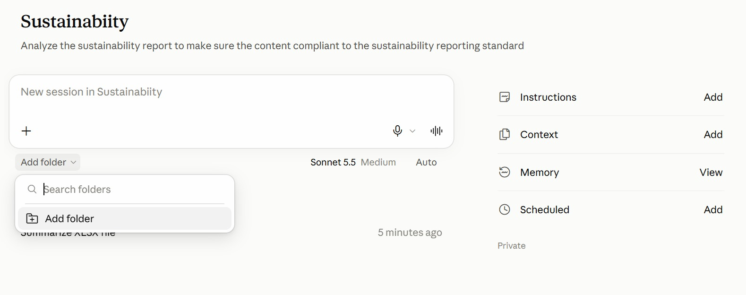
Figure 5 — The Project Page in the App. A project from the class: the goal under its name, the project's panels on the right.
1. Instructions · Context — HOW and WHAT — click Add to write the rules or attach reference files.
2. Add folder — WHERE — under the message box, pick the folder Claude reads from and saves to.
3. Memory · Scheduled — What Claude has learned about the project, and WHEN tasks run on their own.
4. New session — Type in the box to start a session; earlier sessions are listed beneath it.
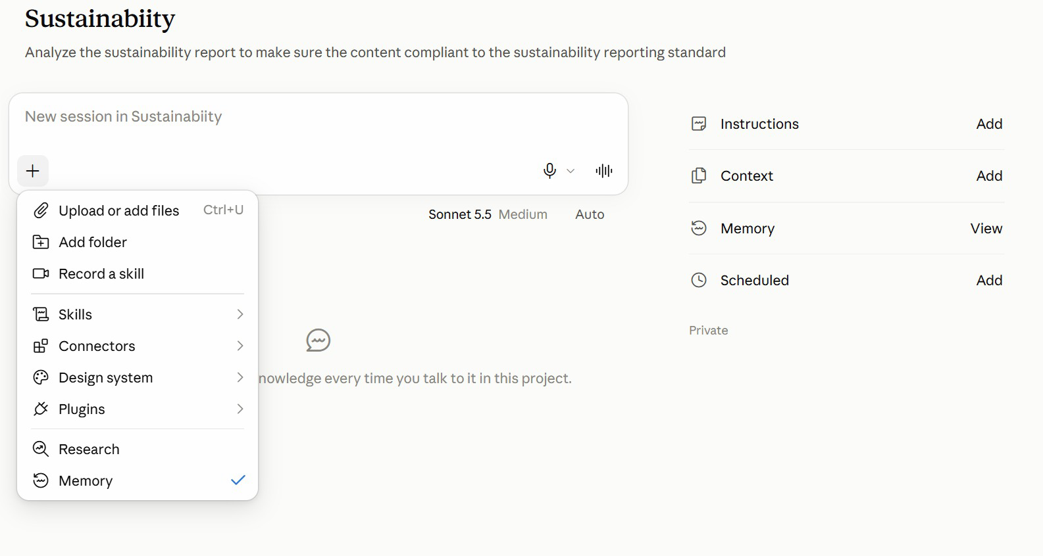
Figure 6 — The + Menu: What a Session Can Use. Click + in the message box to bring files and tools into the session.
1. Files and folders — Upload a file, or add a folder, for this session.
2. Skills · Connectors · Plugins — Choose what the session may use — the brand-voice skill, Gmail, a plugin.
3. Record a skill — Capture a routine you show Claude as a new skill.
4. Research · Memory — Deeper web research; the tick shows the session uses project memory.
When to use a project
Use a project for | Why
A long-running goal | Work keeps arriving for weeks — a product launch, a channel, an app.
A job that splits | One big job breaks into pieces that can run at once — assets, ads, competitors, email.
Lots of research | Many subjects to look into — one task per competitor, market or segment.
Regular routines | Work that repeats on a timetable — scheduled tasks that belong to the project.

A one-off question that is done in one reply? Use an ordinary chat.

The parts of a project
Part | What it is
Instructions | Standing rules you write: brand voice, currency, never publish without approval.
Context | Documents Claude READS and never edits — the brand guidelines, product sheet and launch brief.
Folder | A real folder on your computer where Claude WORKS: it reads the data there and writes output back.
Scheduled | Recurring tasks that belong to this project — the daily post draft, the weekly report.
Tasks | Each job you start in the project. Several can run at once, one per subject.
Memory file | lumo-project-memory.md in the folder: decisions you ask Claude to record, read by every later task.

Creating a project
1. What are you working on? — The project's name — Lumo Cold Kopi Launch. This is how you find it in the sidebar.
2. What are you trying to achieve? — The goal in two or three sentences. Every task in the project inherits it.
3. Use a folder — Point the project at a folder on your computer, so the files and outputs are yours to open.
4. Create project — The project page opens with four panels: Instructions, Context, Folder and Scheduled.
Start a new project from Projects in Cowork. The instructions and context are added afterwards, from the project page.
Instructions or context?
Quick test: a sentence that starts Always, Never or Write in… is an instruction. A document is context.
Instructions — how to behave | Context — what to know
Short standing rules you write in the Instructions panel. | Reference documents Claude reads but never edits.
Followed by every session in the project. | Files you add in the Context panel.
If an output breaks a rule, fix the instruction here. | If a fact in an output is wrong, fix or replace the file.
Keep them short: they are loaded into every session. | Add them once; you never re-attach them again.
Lumo: “Prices in S$. No health claims. Ask before sending.” | Lumo: brand guidelines, product sheet, launch brief.

Instructions, context and memory compared
These three are easy to confuse, and the difference matters: when an output is wrong, it tells you which one to fix.
 | Instructions | Context | Memory file
Who writes it | You | You add it | Claude, when you ask it to
What it holds | Rules and style | Files to read | Decisions and facts to keep
Lumo example | Prices in S$; no health claims | Brand guidelines, launch brief | Launch date moved to 8 December
Edit it in | The Instructions panel | The Context panel | lumo-project-memory.md in the folder
When output is wrong | Tighten the rule | Add the missing file | Correct the line in the file

Where each part lives in Claude
Every part of a project, where you click to find it, and the Lumo example.
Part | Where you find it in Claude | What it does | Lumo example
Project | Cowork → Projects → the project | Stays set up for weeks | Lumo Cold Kopi Launch
Session | A new task inside the project | Starts fresh; the setup still applies | Draft the Instagram post
Instructions | The Instructions panel | How every session must behave | Prices in S$; no health claims
Context | The Context panel | What Claude reads, never edits | Brand guidelines, product sheet
Folder | The Folder panel — a real folder | Where work is done and left | Survey CSV in, posts out
Scheduled | The Scheduled panel | Work that runs on a timetable | Monday 9am: the week's posts
Memory file | lumo-project-memory.md in the folder | Decisions kept between sessions | Launch price confirmed at S$3.90

Creating the project
In Cowork, a project is created from a short dialog with two questions and a folder. The name is how you find it again; the answer to "What are you trying to achieve?" is the standing goal every task in the project inherits.
Point the project at a folder you create for it. That folder is where Claude works — it reads the data you put there and writes every output back — and it stays a normal folder you can open, back up or share.
Example
EXAMPLE — Lumo Kopi
Launch Lumo Cold Kopi in Singapore on 1 December 2026. Produce the
research, launch deck, campaign brief, two weeks of social posts and a
15-second launch video, within a S$60,000 budget, so that 25-34
year-olds on Instagram and TikTok know the product exists by launch day.

How to do it
1. In Cowork, open Projects and start a new project.
2. Type the name, paste the goal into What are you trying to achieve?, and choose Use a folder.
3. Click Create project. The project page opens with its four panels.

Writing project instructions
Instructions are standing rules that apply to every task in the project. Use them for things that are always true: the currency, the brand voice in brief, what must never happen without your approval.
Keep them short and testable. A rule Claude can check — "prices always in S$ with two decimals" — works far better than a wish such as "be professional".
Example
EXAMPLE — Lumo Kopi
You are the marketing team for Lumo Kopi Co.
- Prices are in Singapore dollars: S$3.90 per can, S$42.00 per 12-pack.
- Follow lumo-brand-guidelines.md for anything customer-facing.
- Never describe the product as healthy; you may say 5 g sugar.
- Never send an email or publish a post without my approval.
- Save outputs to the project folder with the date in the filename.

How to do it
1. On the project page, open the Instructions panel.
2. Paste the instructions and save.
3. Start a new task and check that the rules are followed without you repeating them.

Adding context and using the folder
Context is what the project reads: the brand guidelines, the product sheet, the launch brief. Claude reads context but does not edit it, so it is the right home for reference material you want kept exactly as it is.
The Folder is different: it is where Claude works. Data it should analyse and every file it produces live there. Mixing the two up is the most common setup mistake — reference in Context, working files in the Folder.
How to do it
1. On the project page, open Context and add the reference files.
2. Put the lab's data files in the project folder on your computer.
3. Ask: "Which context files and folder files can you see, and what is each one for?"

Keeping a memory file
A classic project has no memory panel of its own, so keep one yourself: a Markdown file in the project folder — lumo-project-memory.md — where Claude records decisions you ask it to remember. Every later task can read it.
Because Claude writes it, check it. Open the file from time to time, correct anything out of date and delete anything you do not want every future task to believe. It is a shared notebook that you are responsible for.
Example
EXAMPLE — Lumo Kopi
Add this to lumo-project-memory.md: the Singapore launch date has moved
from 1 December to 8 December 2026. Update anything you have planned
that depends on it.

How to do it
1. Ask Claude to create lumo-project-memory.md in the project folder (Lab 1 does this).
2. Tell Claude what to record whenever a decision changes.
3. Open the file yourself and correct or delete lines as needed.

Scheduling tasks
A scheduled task is a prompt that runs on a timetable. Pick the project in the task's settings and it runs with the project's instructions, context and folder — you do not repeat them in the task.
Schedule drafts, not publishing. Permissions defaults to Automatically approve, so the task acts unattended: it should prepare today's post and email it to you for approval, and the click that publishes stays yours.
Example
EXAMPLE — Lumo Kopi
Take today's row from social-calendar.csv, polish the post with
lumo-brand-voice, check every price and claim against the brand kit, and
email it to me as a draft with the subject "Today's Lumo post". Never
publish anything.

How to do it
1. Open Scheduled tasks from the sidebar and choose New task → Set up manually.
2. Enter the Name and paste the Instructions; pick the Lumo Cold Kopi Launch project.
3. Change Frequency from Manual to the timetable you want, and check Permissions.
4. Save, then check the email that arrives at the first run.

Coming soon: the new Projects
Anthropic redesigned Claude Projects in September 2026. The new version is in beta, rolling out to Pro and Max accounts first — if your Projects page shows a Goal and talks about threads, you already have it.
Feature | What it does
Lead agent | You state a goal once; a coordinator plans the work, splits it and merges the results.
Parallel threads | The lead agent starts one thread per subject itself — what you do by hand with tasks in Lab 2.
Goal | One outcome statement that every decision in the project steers toward.
Project memory | Memory the project writes and you edit in settings — replacing the memory file you keep in Lab 1.
Usage per thread | Project settings show the tokens used by the lead agent and by each thread.
Cloud environment | Threads keep working in the cloud with your laptop closed.

What changes in the labs
In today's labs (classic) | With the new Projects
Lab 2: you start four tasks, then a merge task | One message; the lead agent starts four threads and merges them
Lab 8: one task drafts all four platforms | One thread per platform, merged into one calendar
lumo-project-memory.md in the folder | Project settings → Memory, editable memory files
Instructions panel | Project instructions under settings, plus a Goal
Settings → Usage for your whole plan | Usage per thread for this project

Everything you build today carries over: skills, connectors, artefacts and scheduled tasks work the same way. The Threads edition of this course runs the same ten labs on the new Projects — see the course repository.

Topic 01 — Claude Projects and Market Research
The Claude family · Projects in Cowork · instructions, context and folder · market research · Live Artefacts
Key concepts
Concept | What it means
Claude Project | A home for a long-running body of work. Its rules, files and outputs build up instead of resetting each chat.
Backed by a folder | In Cowork a project points at a real folder on your computer — Claude works there, and you can open it yourself.
Instructions | Standing rules every task in the project follows: currency, brand voice, approval before sending.
Context vs Folder | Context is what Claude reads and never edits. Folder is where it works — reading data and writing output.
Parallel tasks | Several tasks can run in one project at once — one per subject — and a final task merges their files.
Live Artefacts | Interactive tools — dashboards, trackers — that persist in your workspace instead of scrolling away in chat.

The Claude family
Product | Role | What it does
Claude (Chat + Cowork) | Thinking and work partner — this course | • Chat: ask, draft, analyse and research with web search  • Cowork: plans and runs multi-step tasks on your files  • Projects, connectors and skills: Drive, Gmail, Calendar  • For everyone — web, desktop and mobile apps
Claude Code | Build partner | • Builds software, sites and automations  • Runs in the terminal, VS Code, desktop app and web  • Edits files, runs commands and calls MCP tools  • Extended with CLAUDE.md, skills, sub agents and hooks

Chat and Cowork are now one app: Claude. A marketing team works there — and a Project ties the work together around one goal.

Lab 1 — Set Up the Lumo Launch Project
Objective: By the end of this lab you can create a Claude Project in Cowork with instructions, context, a working folder and a memory file.
Scenario: Lumo Kopi Co. launches Lumo Cold Kopi in six weeks, and the marketing work will keep coming until launch day — exactly what a Claude Project is for. You create the Lumo Cold Kopi Launch project in Cowork, point it at a working folder, write its standing instructions, add the brand kit as context, and check that Claude understood all of it. Every later lab runs inside this project.
You will build: The Lumo Cold Kopi Launch project, with instructions, three context files, a working folder and a project memory file.
Tools: Claude desktop app (Cowork), Claude Projects.
In the project
Part | In this lab
Instructions — HOW | Set up: paste Block 2 into the Instructions panel — S$ prices, brand guidelines, no health claims, approval first.
Context — WHAT | Set up: add the brand kit in the Context panel — guidelines, product sheet and launch brief.
Folder — WHERE | Set up: point the project at your Lumo Launch folder; lumo-project-memory.md starts here.
Scheduled — WHEN | Not yet — Lab 8 adds the first scheduled task.

Lab files
- Prompt PDF: labs/lab-01-set-up-the-launch-project/lab-01-set-up-the-launch-project.pdf
- labs/lab-01-set-up-the-launch-project/data/brand-kit/lumo-brand-guidelines.md
- labs/lab-01-set-up-the-launch-project/data/brand-kit/lumo-product-sheet.md
- labs/lab-01-set-up-the-launch-project/data/brand-kit/lumo-launch-brief.md
Step-by-step
This lab has three blocks. Block 1 is the project goal, pasted into the Create a project dialog. Block 2 is the standing instructions, pasted into the Instructions panel. Block 3 is your first task in the project.
Note: Projects live in Cowork mode in the desktop app. Create an empty folder called Lumo Launch on your computer first — the project works inside it.
1. Download the course labs and open the Lab 01 data/brand-kit folder. Create an empty folder called Lumo Launch on your computer.
Why: Skim the three brand-kit files — you will check Claude's answers against them. The empty folder becomes the project's working folder.
2. In the Claude desktop app, switch to Cowork, open Projects and start a new project.
Why: In Cowork a project is backed by a real folder on your computer, so its files stay yours to open.
3. Under "What are you working on?" type Lumo Cold Kopi Launch, and paste Block 1 into "What are you trying to achieve?".
Why: The goal is the standing context every task inherits, so write it as an outcome with a date and a measure.
Block 1 — GOAL
Paste this into "What are you trying to achieve?" in the Create a project dialog:
PROMPT — copy into Claude
Launch Lumo Cold Kopi in Singapore on 1 December 2026.
Produce the market research, a launch deck, a campaign brief,
two weeks of social media posts and a 15-second launch video,
within a S$60,000 budget, so that 25-34 year-olds on Instagram
and TikTok know the product exists by launch day.

Name it Lumo Cold Kopi Launch, choose Use a folder and pick your Lumo Launch folder, then Create project.
4. Choose Use a folder, pick your Lumo Launch folder, and click Create project.
Why: The project page opens with four panels: Instructions, Context, Folder and Scheduled.
5. Open the Instructions panel and paste Block 2. Save.
Why: Instructions are standing rules for every task. Short, checkable rules work better than general wishes.
Block 2 — INSTRUCTIONS
Paste this into the project's Instructions panel:
PROMPT — copy into Claude
You are the marketing team for Lumo Kopi Co.
- Prices are in Singapore dollars: S$3.90 per can, S$42.00 per
12-pack. Always two decimals.
- Follow lumo-brand-guidelines.md for anything customer-facing.
- Never describe the product as healthy. You may say 5 g sugar.
- Never send an email or publish a post without my approval.
- Save every output to the project folder.
- Read lumo-project-memory.md before you start any task.
- Flag any figure that two sources disagree on. Do not pick one.

Save the instructions, then add the three brand-kit files in the Context panel.
6. Open the Context panel and add the three brand-kit files.
Why: Context is read, never edited — the right home for reference files you want kept exactly as they are.
7. Start a new task in the project and send Block 3.
Why: This is a setup check: if Claude cannot restate the goal or find the files, fix that now, before any real work.
Block 3 — FIRST TASK
Start a new task in the project and send:
PROMPT — copy into Claude
Before we start work, check your setup:
1. Restate the project goal in one line.
2. List the context files you can read and what each is for.
3. List the three instructions you think matter most.
4. From the product sheet, give me the price per can, the sugar
per can and the launch date.
Then create lumo-project-memory.md in the project folder with
the heading "Project memory" and record: our primary audience
is 25-34 year-olds in Singapore, and our secondary market is
Kuala Lumpur, launching 15 January 2027.

Compare the answer with the brand kit, then open your Lumo Launch folder and read lumo-project-memory.md.
8. Check the answers: S$3.90 per can, 5 g sugar, launch 1 December 2026.
Why: Every figure must match the product sheet. A wrong figure here means a wrong context file.
9. Open the Lumo Launch folder on your computer and read lumo-project-memory.md.
Why: A classic project has no memory panel, so this file plays that role: every task reads it (Block 2 says so), and you can edit it.
Check
You are done when: The Lumo Cold Kopi Launch project exists in Cowork, using your Lumo Launch folder, with the Block 2 instructions saved and the three brand-kit files under Context. Claude restated the goal, listed all three context files, and quoted S$3.90 per can, 5 g sugar and a 1 December 2026 launch. lumo-project-memory.md in the folder records the 25-34 audience and the 15 January 2027 Kuala Lumpur launch.

Market research in parallel tasks
In Lab 2 you start four research tasks in the project at once, one per independent subject, then a fifth task merges them:
Task | What it researches
Task 1 — Competitors | Six cold-brew brands: price, pack, positioning, and the gap Lumo can own.
Task 2 — Customers | 400 survey respondents: who is likely to buy, why, and where they discover drinks.
Task 3 — Pricing | Where S$3.90 sits against the market, and what the survey says people will pay.
Task 4 — Social trends | Which content themes earn the most engagement in the category right now.

Start four tasks in the project at once, one subject each, each saving its own file to the folder. A fifth task merges them into the research brief.

Lab 2 — Run Market Research in Parallel Tasks
Objective: By the end of this lab you can split a multi-subject research job into parallel tasks and verify the merged brief.
Scenario: Before anyone writes a post, the team needs to know the market. Four subjects need research — competitors, the customer survey, pricing and social trends — and none depends on another. So you start four tasks in the project at once, one per subject, each saving its findings to the folder. A fifth task merges the four files into one research brief, which you check against the data.
You will build: Four research files and lumo-research-brief.docx merged from them, in the project folder.
Tools: Claude Projects in Cowork, parallel tasks, web search.
In the project
Part | In this lab
Instructions — HOW | Uses: save every output to the folder, and flag any figure two sources disagree on.
Context — WHAT | Uses: the launch brief, so every task knows the product, price and audience.
Folder — WHERE | Adds: copy in the three CSVs; four research files and lumo-research-brief.docx are saved here.
Scheduled — WHEN | Not used — you start the four tasks yourself, now.

Lab files
- Prompt PDF: labs/lab-02-market-research/lab-02-market-research.pdf
- labs/lab-02-market-research/data/lumo-consumer-survey-2026.csv
- labs/lab-02-market-research/data/lumo-competitors.csv
- labs/lab-02-market-research/data/lumo-social-trends.csv
Step-by-step
This lab has five blocks. Blocks 1 to 4 each go into their own new task, started one after another without waiting for the previous one to finish. Block 5 goes into a fifth task once the four research files are in the folder.
Note: Copy the three CSV files from the Lab 02 data folder into your Lumo Launch project folder first.
1. Open the Lab 02 data folder and glance at the three CSV files.
Why: Know your source: 400 survey rows, six competitors, twelve content themes.
2. Copy the three CSV files into your Lumo Launch project folder.
Why: Data Claude analyses belongs in the Folder; the brand kit stays in Context.
3. Start a new task in the project and send Block 1. Do not wait for it.
Why: Each task has one subject and one file — a focused brief with a fresh context window. That is why parallel research stays sharp.
Block 1 — COMPETITORS
Start a new task in the project and send:
PROMPT — copy into Claude
Research COMPETITORS for the Lumo Cold Kopi launch using
lumo-competitors.csv: price per can, pack, positioning and
channel for each brand, and the gap Lumo can own.
Save your findings as research-1-competitors.md in the project
folder.

Do not wait for it — start the next task straight away.
4. Start a second task and send Block 2.
Why: Several tasks can run in one project at the same time.
Block 2 — CUSTOMERS
Start a second task and send:
PROMPT — copy into Claude
Research CUSTOMERS using lumo-consumer-survey-2026.csv: the share
likely to buy (intent 4 or 5), split by age band and city; the
top purchase drivers; the top discovery channels. Show your
working for every percentage. Save your findings as
research-2-customers.md in the project folder.

Start the third task.
5. Start a third task and send Block 3.
Why: Pricing reads both files; it does not need the other tasks' results.
Block 3 — PRICING
Start a third task and send:
PROMPT — copy into Claude
Research PRICING using lumo-competitors.csv and
lumo-consumer-survey-2026.csv: where S$3.90 sits against the
competitor median, and the share of respondents willing to pay
S$3.50 or more. Show your working. Save your findings as
research-3-pricing.md in the project folder.

Start the fourth task.
6. Start a fourth task and send Block 4.
Why: You are now the lead agent: four workers, four subjects, one goal.
Block 4 — TRENDS
Start a fourth task and send:
PROMPT — copy into Claude
Research SOCIAL TRENDS using lumo-social-trends.csv: the three
content themes with the highest engagement, with one post idea
each. Save your findings as research-4-trends.md in the project
folder.

Four tasks are now running at once. Watch them finish in the project's task list.
7. When the four research files are in the folder, start a fifth task and send Block 5.
Why: The merge task reads the files, not the other conversations — so the folder is how the tasks share their work.
Block 5 — MERGE
When all four files are in the folder, start a fifth task and send:
PROMPT — copy into Claude
Merge research-1-competitors.md, research-2-customers.md,
research-3-pricing.md and research-4-trends.md from the project
folder into one research brief, lumo-research-brief.docx:
a one-paragraph summary, one section per subject with the key
numbers, and three recommendations for the launch. Name the
source file under each section, and flag anything the four
files disagree on.

Open the brief and check it against the data in the next steps.
8. When the merged brief arrives, check the survey numbers.
Why: Expect 400 respondents, 248 likely to buy (62%), and 112 of 152 in the 25-34 band (74%).
9. Check the channel, driver and pricing findings.
Why: Instagram 136 (34%), TikTok 104 (26%); Taste 124 (31%); competitor median S$4.30 with S$3.90 below it; 228 (57%) would pay S$3.50 or more.
10. Check the trends section and the recommendations.
Why: The top theme should be Taste tests and first-sip reactions. Do the three recommendations follow from the numbers above them?
Check
You are done when: The project folder holds the four research files and lumo-research-brief.docx, whose summary, four sections and three recommendations name their source files. The brief reports 400 respondents, 248 likely to buy (62%), 112 of 152 aged 25-34 (74%), Instagram as the top discovery channel at 34%, Taste as the top driver at 31%, a competitor median of S$4.30 with Lumo's S$3.90 below it, 228 respondents (57%) willing to pay S$3.50 or more, and Taste tests and first-sip reactions as the top content theme.

Live Artefacts
A Live Artefact is an interactive tool Claude builds and keeps in your workspace. You make one in five moves:
1. Describe — Tell Claude the tool you want — a dashboard, tracker or planner — and what data it shows.
2. Generate — Claude writes the code and renders it in the preview pane beside the chat.
3. Refine — Ask for changes in plain English until the layout and figures are right.
4. Save — Save it so it persists as a reusable tool, not a lost chat message.
5. Download — Export a copy to file, attach or hand on to someone without Claude.
What an artefact can and cannot do
An artefact CAN | An artefact CANNOT
Run interactive code — inputs, filters, charts. | Call an external API or website — the sandbox blocks it.
Use data you gave it, or that Claude looked up while building. | Load a script, font or image from another site.
Keep what you type into it between sessions. | Reach your local files or network.
Be saved, reopened and shared. | Refresh third-party data on its own.
Be downloaded as a file you own.

So: bake the data in, or download the HTML and run it yourself.

Lab 3 — Build the Market Insights Live Artefact
Objective: By the end of this lab you can turn research data into an interactive Live Artefact dashboard and save it.
Scenario: The research brief is a document; the launch team wants something they can explore. You turn the survey and competitor data into a Live Artefact — KPI tiles, a channel chart, a price ladder and a city filter — refine it in plain English, save it and download a copy. The launch deck in Lab 5 quotes this dashboard's numbers.
You will build: A saved Market Insights Live Artefact, plus a downloaded HTML copy.
Tools: Claude Projects, Live Artefacts.
In the project
Part | In this lab
Instructions — HOW | Uses: S$ prices with two decimals on every tile and chart.
Context — WHAT | Uses: the product sheet, for Lumo's own price beside the competitors.
Folder — WHERE | Uses: the survey and competitor CSVs in the folder; save the HTML copy here too.
Scheduled — WHEN | Not used — runs when you send the prompt.

Lab files
- Prompt PDF: labs/lab-03-market-insights-artefact/lab-03-market-insights-artefact.pdf
- labs/lab-03-market-insights-artefact/data/lumo-consumer-survey-2026.csv
- labs/lab-03-market-insights-artefact/data/lumo-competitors.csv
Step-by-step
1. In the project, send the lab prompt with the two CSV files attached or in Context.
Why: The project already knows the brand colours from the guidelines in Context — you do not attach them again.
PROMPT — copy into Claude
Using lumo-consumer-survey-2026.csv and lumo-competitors.csv, build
a Live Artefact: an interactive Market Insights dashboard for the
Lumo Cold Kopi launch.

Include:
- KPI tiles: respondents, % likely to buy (intent 4 or 5), top
discovery channel, competitor median price.
- A bar chart of discovery channels.
- A bar chart of purchase drivers.
- A price ladder: the six competitors and Lumo at S$3.90, cheapest
to dearest, with Lumo highlighted.
- A filter for city: All, Singapore, Kuala Lumpur. The KPI tiles and
both survey charts must follow the filter.

Bake the data into the artefact - do not fetch anything. Use the
Lumo brand colours from the brand guidelines. Title it
"Lumo Cold Kopi - Market Insights".

Note: Artefacts run in a sandbox and cannot call the internet, which is why the prompt says to bake the data in.
2. Check the KPI tiles with the filter on All.
Why: 400 respondents, 62% likely to buy, Instagram top channel, competitor median S$4.30 — the same numbers as the Lab 2 brief.
3. Switch the filter to Singapore, then Kuala Lumpur.
Why: The respondents tile should read 240, then 160. If a chart does not change, ask Claude to wire it to the filter.
4. Check the price ladder.
Why: Kopi Kaki Cold at S$3.20 is cheapest, Northpoint Cold Brew at S$5.60 is dearest, and Lumo sits third at S$3.90, between Daily Grind RTD at S$3.70 and Frostbean at S$4.20.
5. Ask for one refinement, for example: Put the price ladder beside the channel chart.
Why: Refining by conversation is the normal way to work — you never edit the code yourself.
6. Save the artefact, then download a copy as HTML.
Why: A saved artefact persists and can be reopened; the download is a file you can share with someone who does not use Claude.
Check
You are done when: The Market Insights artefact shows 400 respondents, 62% likely to buy, Instagram as the top channel and a S$4.30 competitor median. The city filter changes the respondent count to 240 (Singapore) and 160 (Kuala Lumpur) and both survey charts follow it. The price ladder runs from S$3.20 to S$5.60 with Lumo highlighted at S$3.90. The artefact is saved and an HTML copy is downloaded.

From the class
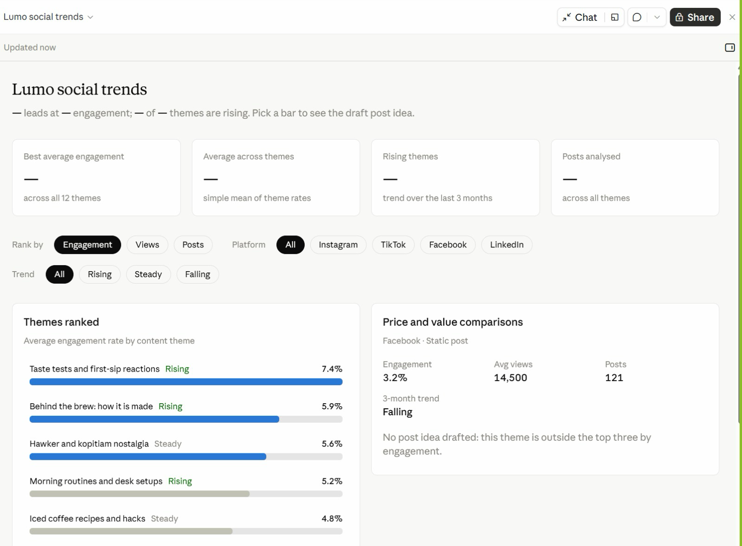
Figure 7 — From the Class: Lumo Social Trends. A Live Artefact built in class from the social trends research.
1. Filters — Rank by engagement, views or posts; filter by platform and trend.
2. Themes ranked — Taste tests and first-sip reactions lead at 7.4%, and are rising.
3. Pick a bar — The right-hand card shows that theme's numbers and a draft post idea.
4. Spot the gap — The summary cards show '—'. Ask Claude to fix them — always check the numbers.
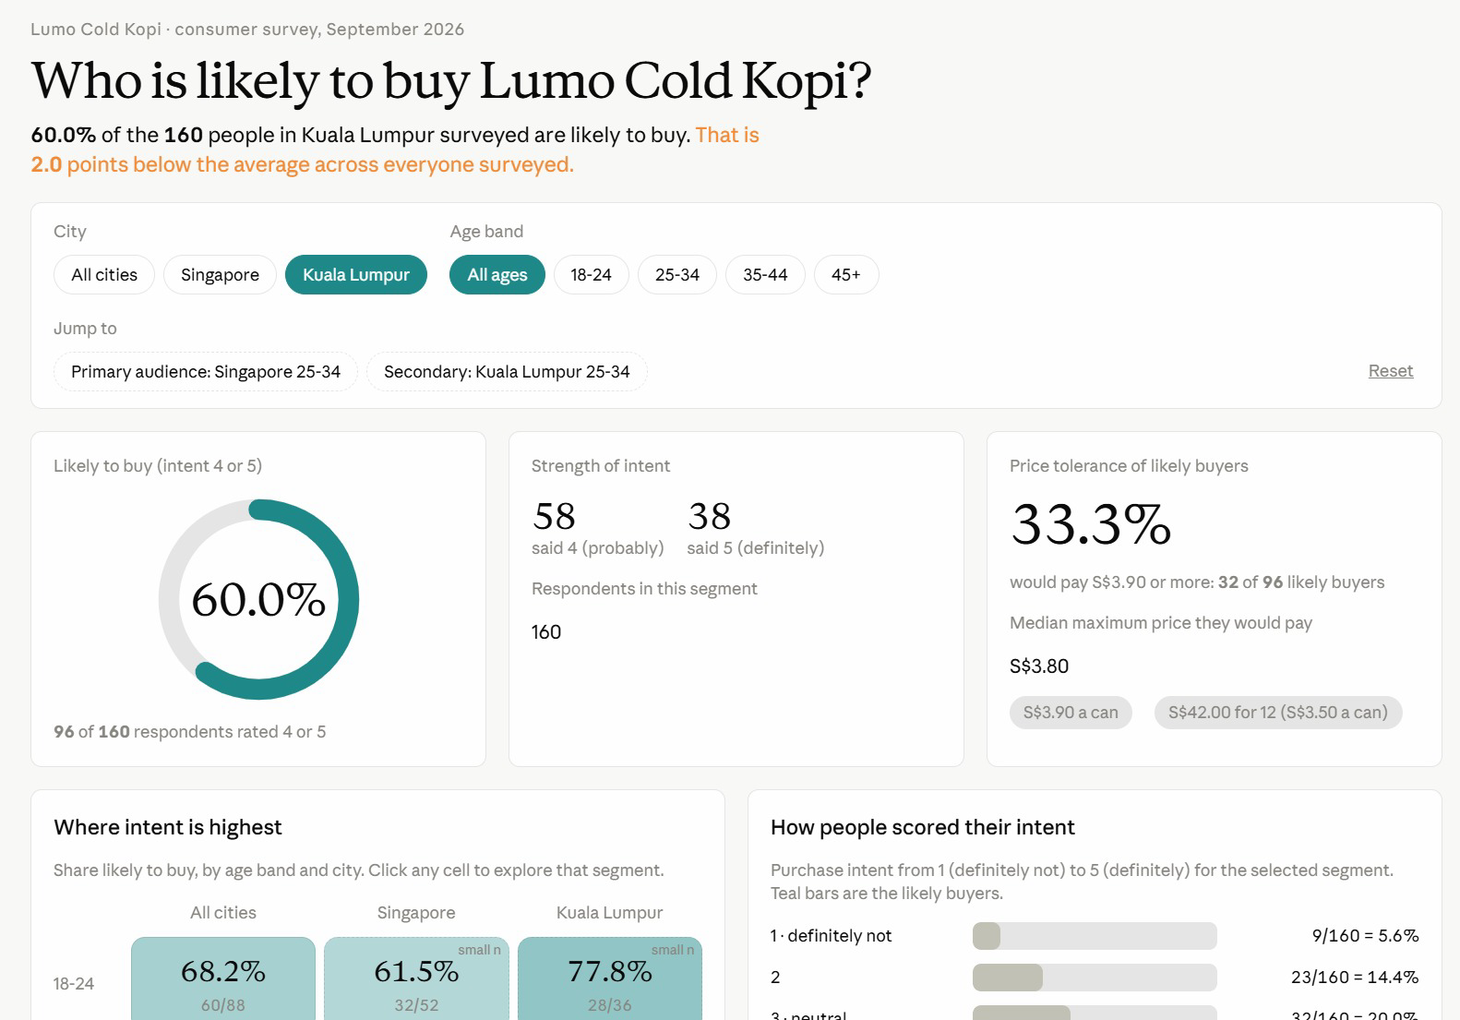
Figure 8 — From the Class: Who Is Likely to Buy?. A Live Artefact on the consumer survey, filtered here to Kuala Lumpur.
1. Filters — City and age band; Jump to opens the primary and secondary audiences.
2. Headline — 60.0% of 160 KL respondents are likely to buy — 2 points below the overall average.
3. Price tolerance — A third of likely buyers would pay S$3.90 or more.
4. Explore — Click any city and age cell to open that segment; small samples are flagged.
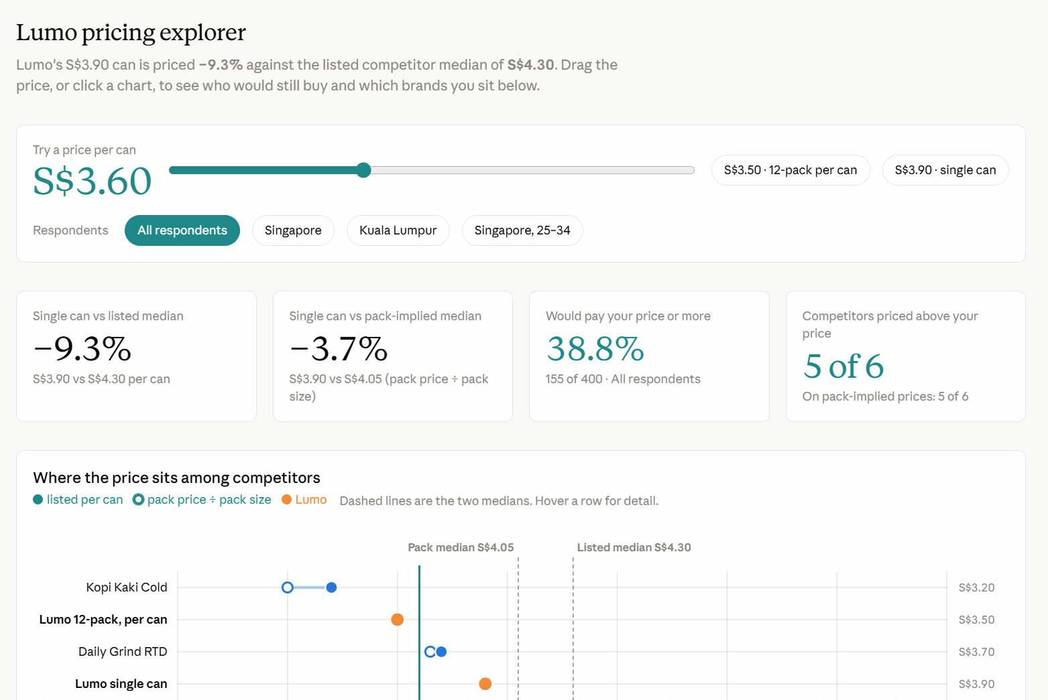
Figure 9 — From the Class: Lumo Pricing Explorer. Drag the price and every card recalculates who would still buy.
1. Price slider — Drag it, or pick S$3.50 (12-pack) or S$3.90 (single can).
2. Against competitors — Lumo's S$3.90 can is 9.3% below the S$4.30 competitor median.
3. The chart — Listed and pack prices per can, with both medians as dashed lines.
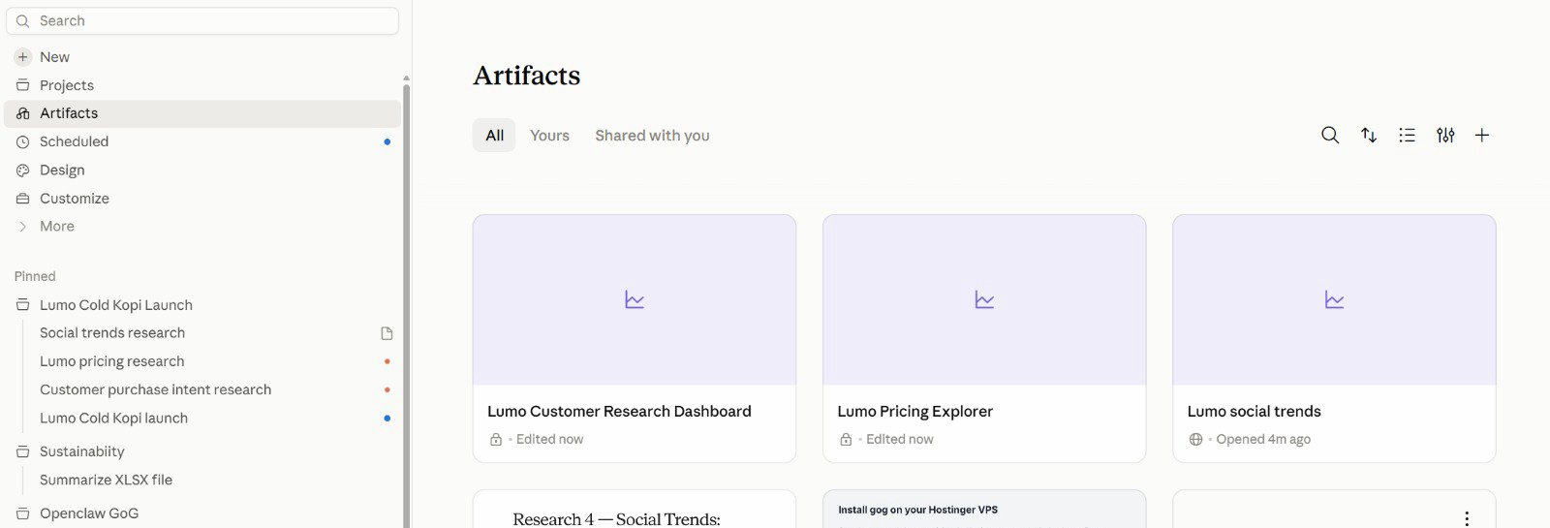
Figure 10 — All Your Artefacts in One Place. Artifacts in the sidebar lists everything you have built, across every project.
1. Artifacts — Open, search, sort and filter all your artefacts.
2. Lock or globe — A lock means private; a globe means shared by link.
3. Pinned — The Lumo project and its sessions stay pinned in the sidebar.

Topic 02 — Connectors, Skills and Plugins
Claude's tools · Drive and Gmail · tool calls · data analysis · the context window · Slides and Docs · Agent Skills · plugins and mods
Key concepts
Concept | What it means
Tools | What Claude can DO: search the web, run code, create files — and reach Drive or Gmail through a connector.
Tool calls | Each action shows as a step in Claude's reply. Click it to see the tool, its input and what came back.
Connectors and approval | Drive and Gmail add their own tools. Reading runs freely; sending an email waits for your approval.
Data analysis | Claude writes and runs code on your CSV or Excel file, so the numbers are calculated — and you can check the code.
Skills | HOW Claude does a job: a SKILL.md of steps, rules and checks, loaded when your request matches its description.
Built-in skills | pptx, xlsx and docx load by themselves when you ask for a deck, a workbook or a document.
/skill-creator | Do the task once, verify it, save it as a skill — then use it, find the gaps and update it.
Plugins and mods | A plugin bundles skills and tools someone packaged. A mod changes Claude's own interface.

Tools and skills
Two words run through this topic. A tool is one action Claude can take; a skill is the know-how for a whole job, which tells Claude which tools to use and in what order.
A tool — what Claude can DO | A skill — HOW Claude does a job
One action: search, read, run code, create a file, send. | A SKILL.md of steps, rules and checks for one kind of job.
Built in (web search, code, files) or added by a connector. | Built in (pptx, xlsx), written by you, or from a plugin.
Claude picks one by matching your request to its description. | Loads when your request matches its description.
Each call shows in the reply: the tool, its input, its result. | Tells Claude which tools to use, in what order.
Lumo: Google Drive search_files finds the budget sheet. | Lumo: lumo-brand-voice applies the rules to every post.

Claude's built-in tools
Claude can already do these before you connect anything:
Tool | What it does
Web search and fetch | Finds and reads current web pages — competitor news, prices, trends — and cites them.
Code execution | Writes and runs Python on your files: counts, tables, charts. Lab 3's dashboard, Lab 5's analysis and Lab 9's video.
File creation | Makes real .xlsx, .pptx, .docx and .pdf files you download and open. Lab 5.
Artefacts | Builds an interactive page — a dashboard, a tracker — that stays in your workspace. Lab 3.
Project files | Reads the project's context and writes outputs to its files — the brief, the calendar. Every lab.
Connectors | Add more tools from outside apps: Google Drive, Gmail, Calendar and others. Lab 4.

How Claude uses a tool
1. You ask — “Compare the Drive budget with the brief.”
2. Claude picks a tool — It matches the job to each tool's description — here, Google Drive.
3. It calls the tool — With inputs it chooses: search_files, query “Lumo Launch”.
4. It reads the result — Two CSV files come back — so it calls read_file_content next.
5. It answers, or asks — Reading just runs. Sending an email waits for your approval.
Every tool call appears as a step in Claude's reply. Click it to see the tool, what Claude passed in and what came back. These are the calls behind Lab 4, Block 1:
WHAT CLAUDE DID — the tool calls behind Lab 4, Block 1
1. Google Drive · search_files("Lumo Launch")
→ 1 folder with 2 CSV files
2. Google Drive · read_file_content(lumo-launch-budget.csv)
→ 5 lines, total S$60,000
3. Google Drive · read_file_content(lumo-launch-timeline.csv)
→ 11 milestones; the next is 30 October
4. Project file · read(lumo-launch-brief.md)
→ budget table, total S$60,000
Claude compares the two → 2 lines disagree
5. Google Drive · create_file(lumo-research-brief.docx)
6. Gmail · create_draft("Lumo launch - research and budget check")
7. Gmail · send_message → waits for your approval

Note: Click any step in Claude's reply to see this for yourself. Tool names can differ slightly between connector versions; the pattern does not.

Connectors and the context window
A connector adds tools that reach a service outside the chat. These are the ones this course uses:
Connector | What Claude can do
Google Drive | Search and read Sheets, Docs, Slides and PDFs; upload files; create folders; save Claude's output back to Drive.
Gmail | Search and read mail, draft messages, send / reply / forward with approval, and manage labels.
Google Calendar | View events, find availability, and create or update meetings.
Social and ads tools | Where your workspace has them, connectors for scheduling and ad platforms reach the same way — always with approval.
Approval by default | Claude asks for explicit approval before it sends, replies to or forwards an email.
Where to manage them | Individually from the + menu; account-wide under Customize → Connectors.

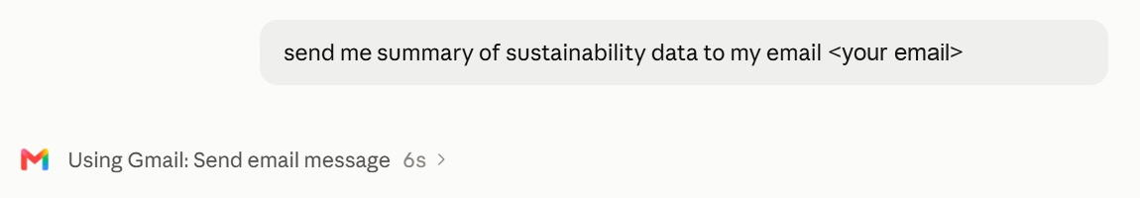
Figure 11 — A Connector at Work: Gmail. One plain request — Claude chose the Gmail connector's Send email action.
1. Ask in plain English — Say what to send and to whom; no menus to find.
2. Watch the tool call — 'Using Gmail: Send email message' names the connector and action. Click › for detail.
3. Stay in control — Ask for a draft first when the email goes to anyone but you.
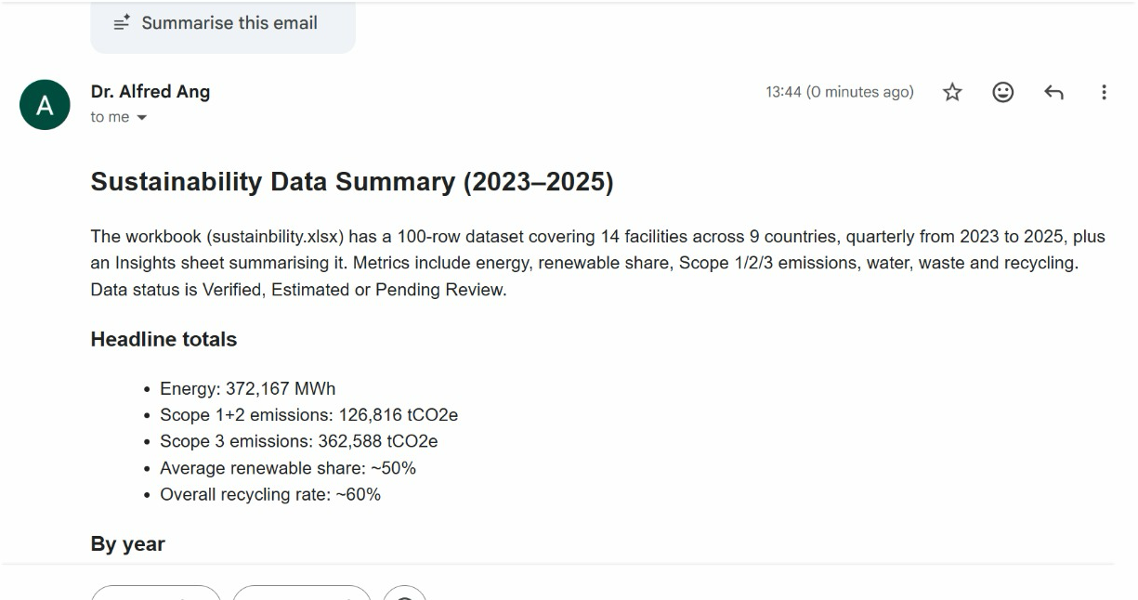
Figure 12 — The Result in Gmail. The summary arrived seconds later, written from the project's sustainability workbook.
1. Read from the file — Claude summarised the workbook: 14 facilities in 9 countries, 2023–2025.
2. Ready to read — Headings and bullets, formatted for email.
3. Verify — Spot-check one total against the source file before you forward it.
Tool permissions and approval
Rule | In practice
Read tools run | Search, read and list change nothing, so they run without asking.
Write tools ask | Send, reply, create an event or delete ask for your approval by default.
See every tool | Customize → Connectors → open a connector to see each tool it adds and what it may do.
On per session | Toggle a connector on from the + menu only for the jobs that need it.
Scope the data | Name the folder, label or dates — “the Lumo Launch folder”, not “my Drive”.
You approve | Read the draft before you click. Claude drafts; the decision stays yours.

Connectors at work: six everyday jobs
Each of these is one prompt once the connectors are on. Lab 4 runs three of them on the Lumo files.
Everyday job | Tools | The prompt you would send
Meeting prep | Gmail · Calendar | Before my 3pm with Kopi Corner, summarise this month's emails with them and list the open questions.
Inbox triage | Gmail | Find customer emails from the last three days that have no reply, and draft replies for my approval.
Budget check | Drive | Compare the Q4 budget sheet with the brief, line by line, and flag every difference. Do not pick one.
Find a file | Drive | Find the latest signed stockist agreement and tell me its renewal date and notice period.
Book a meeting | Calendar · Gmail | Find 45 minutes next week when the four leads are free, and draft the invite.
Weekly update | Drive · Gmail | Summarise what changed in the Lumo Launch folder this week and draft the email to my manager.

When a tool goes wrong
What you see | Likely cause | What to do
“Insufficient scope” | Connected without file access | Settings → Connectors → Reconnect, and accept read access.
An answer with no Drive step | Connector off for this session | + → Connectors → switch it on; start with “Using Google Drive…”.
It read the wrong file | The search matched several files | Name the folder and file: Lumo Launch/lumo-launch-budget.csv.
Numbers that look estimated | No code was run | Ask it to use code and show the totals; check one figure yourself.
Slow replies, usage drains fast | Too many connectors switched on | Turn off the ones this job does not need.

Keeping the context window lean
The context window is all the information the model can “see” when producing a response. Five levers decide what goes into it:
Lever | What it adds
Conversation | Your prompt. The messages you send, including both text and attachments.
Project context | The files the project reads, and the folder it works in.
Connectors | The connected tools Claude can pull data from, and take actions in.
Skills | A set of instructions Claude follows for a repeatable workflow.
Instructions & memory file | Project rules you wrote, and decisions kept in the memory file.

Every lab today pulls one of these levers — context in Lab 1, connectors in Lab 4, skills in Labs 5–7, and the memory file in Lab 10.
A window that fills up costs you in four ways:
Problem | What happens
Context rot | Performance degrades. Recall of specific facts gets worse, the model starts confusing similar entities, and reasoning quality drops.
Tool confusion | Claude sees every tool definition. The more options competing for its attention, the more likely it picks the wrong one or fills in the wrong parameters.
Slower responses | The model processes every token on every turn. A bigger context means more work per message, which means longer waits before you see a reply.
Eats up your usage faster | Your entire context gets resent with each new message — so more tokens are burned per turn, and your limits are reached sooner.

The fix is housekeeping: one job per task, only the connectors you need, and only the files the job actually reads.

Lab 4 — Connect Google Drive and Gmail
Objective: By the end of this lab you can connect Google Drive and Gmail and use their tools to reconcile, search, save and draft, sending only what you approve.
Scenario: The launch budget and timeline live in Google Drive. You connect Drive and Gmail, and the project reconciles the Drive budget against the launch brief — they disagree on two lines — saves the research brief to Drive and emails you an approved summary. Then two everyday jobs: find the next milestones in Drive and draft a reminder in Gmail, reading the tool calls behind each.
You will build: Drive and Gmail connected, the budget reconciled, an approved summary emailed to yourself, a milestone list from Drive and a reminder saved as a Gmail draft.
Tools: Claude Projects, Google Drive connector, Gmail connector, tool calls.
In the project
Part | In this lab
Instructions — HOW | Uses: never send without approval — Claude drafts the email, you approve it.
Context — WHAT | Uses: the launch brief's budget, compared line by line with the Drive sheet.
Folder — WHERE | Reaches out: the Lumo Launch folder in Google Drive and your Gmail, by connector.
Scheduled — WHEN | Not used — runs when you send the prompt.

Lab files
- Prompt PDF: labs/lab-04-connect-drive-and-gmail/lab-04-connect-drive-and-gmail.pdf
- labs/lab-04-connect-drive-and-gmail/data/Lumo Launch/lumo-launch-budget.csv
- labs/lab-04-connect-drive-and-gmail/data/Lumo Launch/lumo-launch-timeline.csv
Tips
Turning connectors on
Click the + in the chat composer, hover Connectors, and toggle on only Google Drive and Gmail. You can manage them later under Customize → Connectors.
If Claude says "insufficient scope"
The connector is linked but was authorised without permission to read files. Fix it in Settings → Connectors → Google Drive → Reconnect, and accept the read access Google asks for. Then tell Claude to try again.
Seeing the tools Claude used
Every tool Claude calls appears as a step in its reply, such as *Searched Google Drive*. Click the step to see the tool's name, what Claude passed in and what came back.
Step-by-step
This lab has three blocks. Block 1 reconciles the budget and emails you an approved summary. Block 2 searches Drive for the milestones due next and asks Claude to list the tools it called. Block 3 searches Gmail and saves a reminder as a draft.
Note: Replace <YOUR EMAIL> with your own address in Blocks 1 and 3. Send lab emails only to yourself.
1. Upload the Lab 04 data/Lumo Launch folder to your Google Drive.
Why: In real work the files are already there; the upload stands in for the shared team drive.
2. In the project, click + → Connectors and switch on Google Drive and Gmail, signing in to Google.
Why: Accept the read access Google asks for. A connector that shows Connected without read access fails with "insufficient scope".
3. Send Block 1 with your own email address in place of <YOUR EMAIL>.
Why: No files are attached this time — the project reaches Drive itself.
Block 1 — RECONCILE
Send this in the project:
PROMPT — copy into Claude
Using Google Drive, open the "Lumo Launch" folder.

1. Read lumo-launch-budget.csv and lumo-launch-timeline.csv.
2. Compare the budget sheet, line by line, with the budget in
lumo-launch-brief.md from our project context. Show both in one
table and flag every line where they disagree. Do not decide
which is right.
3. Upload lumo-research-brief.docx from Lab 2 into the same Drive
folder.
4. Draft an email to <YOUR EMAIL> with the subject
"Lumo launch - research and budget check": three bullet points
from the research brief, the budget table with the disagreements
flagged, the next milestone from the timeline, and a link to the
brief in Drive.

Show me the draft. Do not send it until I approve.

Read the budget table and the draft in full before you approve the email.
4. Read the budget table Claude produces.
Why: Both total S$60,000, but Instagram is S$18,000 in the Drive sheet and S$20,000 in the brief, and Influencers is S$12,000 against S$10,000.
5. Confirm Claude flagged both lines instead of choosing one.
Why: That is your Lab 1 instruction at work. Two sources disagreeing is a decision for a human, not a guess for Claude.
6. Check that lumo-research-brief.docx now sits in the Lumo Launch folder in Drive.
Why: Saving outputs back to the team's folder is what makes the work findable by colleagues.
7. Read the draft email in full, then approve it.
Why: Gmail sends only after your explicit approval. Check the figures against the table before you click.
8. Open your inbox and confirm the email arrived with the Drive link working.
Why: Close the loop: an email you did not check arrived is an email you hope arrived.
9. Send Block 2 to find the milestones due from 6 to 20 November.
Why: The prompt names no file. Claude must search Drive, then read what it found — two tool calls you never asked for by name.
Block 2 — FIND
Then send:
PROMPT — copy into Claude
Search my Google Drive for the Lumo launch timeline.

1. List every milestone due from 6 to 20 November 2026 in a
table: date, milestone, owner and status.
2. Then list the tools you called to answer this, in order:
the tool's name, what you passed to it, and what it returned.

Click the Drive steps in Claude's reply and compare them with the tool list it gave you.
10. Click the Drive steps in Claude's reply and compare them with the tool list it gave you.
Why: Each step shows the tool, its input and its result — a search, then a file read. This is how you check where an answer came from.
11. Check the milestone table.
Why: Three milestones, all Not started: 6 November, launch deck and campaign brief (Marketing lead); 13 November, brand-voice skill and social calendar (Social lead); 20 November, creator content approved (Partnerships lead).
12. Send Block 3 with your own email address in place of <YOUR EMAIL>.
Why: Two Gmail tools this time — one searches your mail, one creates a draft — plus a Drive read. None of them sends anything.
Block 3 — REMIND
Then send:
PROMPT — copy into Claude
Using Gmail and Google Drive:

1. Search my Gmail for the email with the subject
"Lumo launch - research and budget check" and tell me when
it arrived.
2. From lumo-launch-timeline.csv in Drive, find the milestone for
the Shopee and Lazada store pages: its owner and due date.
3. Draft an email to <YOUR EMAIL> with the subject
"Reminder: store pages due <due date>", reminding its owner
of what is due and when.

Save the reminder as a Gmail draft. Do not send it.

Open Gmail → Drafts and check the reminder is there, unsent.
13. Open Gmail → Drafts and check the reminder.
Why: The store pages belong to the E-commerce lead and are due Friday 27 November 2026. The reminder is a draft, not a sent email, and Claude reported when the Block 1 email arrived.
Check
You are done when: Google Drive and Gmail are connected. Claude read both CSV files from the Lumo Launch folder, showed a budget table totalling S$60,000 on both sides, and flagged Instagram (S$18,000 vs S$20,000) and Influencers (S$12,000 vs S$10,000) without choosing between them. lumo-research-brief.docx is in the Drive folder, and the approved summary email arrived in your own inbox with a working link. Block 2 listed the three milestones due from 6 to 20 November with their owners and named the Drive tools it called. Block 3 found the Block 1 email in Gmail and saved a reminder about the E-commerce lead's store pages, due 27 November 2026, as a draft — nothing else was sent.

From the class
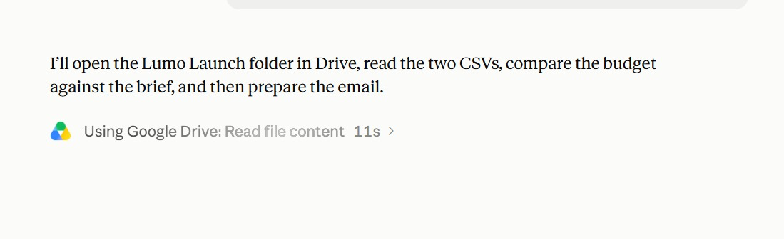
Figure 13 — Lab 4 in Class: Reading from Google Drive. Claude states its plan, then calls the Google Drive connector.
1. Plan first — Open the Lumo Launch folder, read both CSVs, compare the budget with the brief, then email.
2. The tool call — 'Using Google Drive: Read file content' — the connector at work.
3. Watch it — Each tool call shows its time; click › to see what was read.
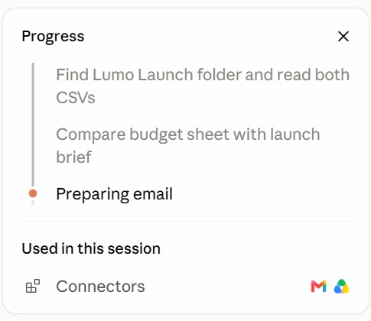
Figure 14 — Following the Progress Panel. The progress panel ticks off each step and lists what the session used.
1. Steps — Find the folder → compare budget and brief → prepare the email.
2. Current step — The orange dot marks the step in progress.
3. Used in this session — The connectors it called: Gmail and Google Drive.
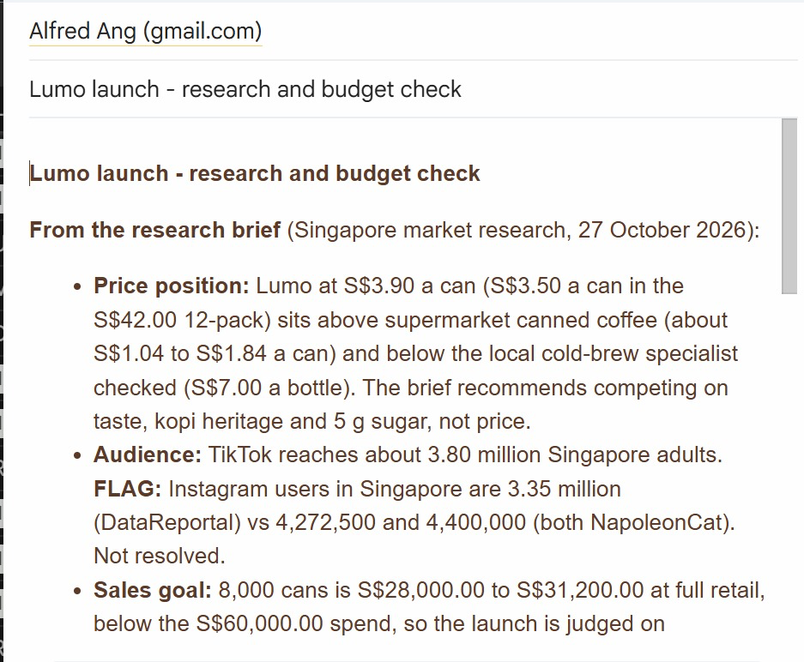
Figure 15 — The Lab 4 Email. The research and budget check, written into Gmail from the Drive files.
1. From the brief — Price position, audience and sales goal, quoted from the research brief.
2. FLAG — Conflicting Instagram figures are flagged, not hidden — resolve each FLAG.
3. The numbers — 8,000 cans is S$28,000–31,200 at retail, below the S$60,000 spend.

Analysing data with Claude
Ask Claude a question about a CSV or Excel file and it uses its code tool: it writes Python, runs it on the file and reads the result. The work runs in five moves:
1. Attach the data — A CSV or Excel file — the 400-row Lumo survey.
2. Define the terms — “Likely to buy” means intent 4 or 5 — say so.
3. Claude runs code — Python reads the file, counts, and draws the chart.
4. Check the method — Click the code step: right column, right filter?
5. Take the output — Tables, a chart, and an .xlsx workbook to download.
The numbers come from code that ran on your file — not from the model's memory.
Six questions to ask of your data
Question type | The prompt you would send
Segment | Likely to buy by city and by age band — count, base and %.
Compare | Which discovery channel has the highest average purchase intent?
Threshold | What share would pay S$3.50 or more, by city?
Clean | Find duplicate respondent IDs, blanks and impossible values. List them; do not delete.
Trend | Chart responses per week from response_date and tell me if any week is unusual.
Report | Save the tables and one chart as an Excel workbook with a Summary sheet.

Four checks before you trust the numbers
Check | How
Define every term | “Likely to buy” must mean intent 4 or 5 — write it in the prompt, or Claude chooses for you.
Ask for the base | A percentage without its count and base cannot be checked: 63% of what? Ask for 152 of 240.
Reconcile the totals | The segments must add back to the whole: 240 + 160 = 400 respondents, 152 + 96 = 248 likely to buy.
Check one figure yourself | Filter the CSV in Excel for one row of the table. If it matches, you can trust the method.

Slides, Docs and built-in skills
Format | What it is
Slides | A deck Claude builds and you edit in place — download as PowerPoint or PDF for the meeting.
Docs | A living document — a campaign brief, a plan — that you and Claude edit and comment on together.
Dashboards | A page of live numbers — the Live Artefact you build in Lab 3 is one.
Built-in skills | Claude's pptx, docx and xlsx skills load on their own when your request needs a file.

You never name the skill. Ask for a deck or a document; Claude picks the format and the skill that builds it.

Lab 5 — Analyse the Survey, Then Build the Deck and Brief
Objective: By the end of this lab you can analyse survey data with Claude's code tool and save it to Excel, then produce a launch deck in Slides and a campaign brief in Docs.
Scenario: Before the deck, the numbers. Claude analyses the 400-row survey by writing and running code, and saves the tables and a chart as an Excel workbook. Then it builds the Friday deck in Slides and the campaign brief in Docs, choosing its built-in skills itself. You check every figure and download the deck as PowerPoint.
You will build: A survey analysis workbook (lumo-survey-analysis.xlsx), an eight-slide launch deck in Slides (downloaded as .pptx) and a campaign brief in Docs.
Tools: Claude Projects, code execution, built-in skills (xlsx, pptx, docx), Slides, Docs.
In the project
Part | In this lab
Instructions — HOW | Uses: follow the brand guidelines for anything customer-facing.
Context — WHAT | Uses: the brand kit, for the name, tagline, price and claims.
Folder — WHERE | Uses: the survey CSV and lumo-research-brief.docx; save lumo-survey-analysis.xlsx and the .pptx here.
Scheduled — WHEN | Not used — runs when you send the prompt.

Lab files
- Prompt PDF: labs/lab-05-launch-deck-and-brief/lab-05-launch-deck-and-brief.pdf
- labs/lab-05-launch-deck-and-brief/data/lumo-consumer-survey-2026.csv
Step-by-step
This lab has two blocks. Block 1 has Claude analyse the survey by writing and running code, and save the result as an Excel workbook. Block 2 builds the launch deck and the campaign brief.
Note: You do not name a skill in either block. Ask for a workbook, a deck or a document; Claude picks the format and the built-in skill.
1. In the project, attach lumo-consumer-survey-2026.csv and send Block 1.
Why: Everyone analyses the same 400-row survey. Claude's code tool writes Python, runs it on the file and reads the result — you never write the code.
Block 1 — ANALYSE
Attach lumo-consumer-survey-2026.csv and send:
PROMPT — copy into Claude
Analyse the attached survey with code. Count "likely to buy" as
purchase_intent 4 or 5.

1. Likely to buy by city, and by age band: count, base and %.
2. Willing to pay S$3.50 or more (max_price_sgd), by city.
3. Likely to buy among 25-34s in Singapore only.
4. One chart: likely-to-buy % by age band.
5. Save it all as lumo-survey-analysis.xlsx: a Summary sheet,
one sheet per table, and the chart.

Show the totals so I can check them, then give me three
findings in one sentence each.

Click the code step and check the totals before you use any number.
2. Click the code step in Claude's reply and read what it ran.
Why: Find the line that counts purchase_intent 4 or 5. Checking the method is how you know the numbers were calculated, not guessed.
3. Check the tables against these figures.
Why: Singapore 152 of 240 (63%), Kuala Lumpur 96 of 160 (60%). By age: 18-24 60 of 88 (68%), 25-34 112 of 152 (74%), 35-44 50 of 96 (52%), 45+ 26 of 64 (41%). Would pay S$3.50 or more: Singapore 143 (60%), Kuala Lumpur 85 (53%). 25-34s in Singapore: 72 of 96 (75%).
4. Download lumo-survey-analysis.xlsx and open it in Excel.
Why: The xlsx built-in skill made a real workbook: a Summary sheet, one sheet per table and the chart.
5. Ask one follow-up question about the data: Which coffee frequency group is most likely to buy?
Why: Expect 1-2 times a week at 52 of 76 (68%), with daily drinkers lowest at 90 of 156 (58%). Follow-up questions are cheap — the data is already loaded.
6. Send Block 2.
Why: No attachments: the research brief, the dashboard data and the brand kit are all already in the project.
Block 2 — BUILD
Then send:
PROMPT — copy into Claude
Using our research brief, the Market Insights dashboard and the
brand kit, create two things for Friday's launch meeting.

1. A launch deck in Slides, eight slides:
1 Title - Lumo Cold Kopi: Kopi, Chilled Right
2 The opportunity - the three survey numbers that matter most
3 Who we are for - 25-34s in Singapore, with the evidence
4 Competitors - a price ladder chart with Lumo highlighted
5 Where they find us - a discovery channel chart
6 The campaign - message, channels and dates
7 Budget - the S$60,000 split, noting the two open questions
8 Next steps and owners

Use the Lumo brand colours. Real charts, not pictures of charts.

2. A campaign brief in Docs: objective, audience, key message,
proof points, channels, budget, timeline, KPIs, and a "claims
we must not make" section.

Every number must come from the research brief or the dashboard.
List the source of each number at the end of the brief.

Check every figure against the research brief and your analysis.
7. Open the deck when it appears and page through all eight slides.
Why: Check the charts are real charts — click one; a real chart has editable data behind it.
8. Check slide 2 and slide 4 against your research.
Why: 62% likely to buy, 74% among 25-34s, Instagram 34%; a price ladder from S$3.20 to S$5.60 with Lumo at S$3.90.
9. Check slide 7.
Why: The S$60,000 split should carry the two open questions from Lab 4 — Instagram and Influencers — not quietly pick one figure.
10. Open the campaign brief in Docs and read the "claims we must not make" section.
Why: It should rule out "healthy" and any claim the product sheet does not support. This section protects every post you write later.
11. Ask for one change to each, for example: Shorten slide 6 to three bullets.
Why: Slides and Docs are edited in place by conversation, the same way as an artefact.
12. Download the deck as PowerPoint and open it.
Why: The download is the file you take into the meeting — check the charts survived.
Check
You are done when: The analysis shows Singapore 152 of 240 (63%) and Kuala Lumpur 96 of 160 (60%) likely to buy, 25-34s at 112 of 152 (74%) and 72 of 96 (75%) among 25-34s in Singapore, and lumo-survey-analysis.xlsx opens in Excel with a Summary sheet, the tables and a chart. The deck has eight slides in the Lumo colours, with real charts for the price ladder and the discovery channels, the survey figures 62%, 74% and 34%, and a budget slide that shows S$60,000 with the Instagram and Influencers lines marked as open questions. The campaign brief in Docs has all nine sections, including "claims we must not make", and lists a source for every number. The deck opens in PowerPoint with its charts intact.

Agent Skills
An Agent Skill is a folder of instructions Claude loads on demand, so a routine runs the same way every time. A skill has three layers, and only the first is always in context:
Layer | What it holds | When Claude loads it
Metadata | Skill name and description. | Always in context — this is all Claude sees until the skill is triggered.
Instructions | The step-by-step workflow, written in a SKILL.md. | Loaded when the skill is triggered.
Resources | Supporting documents, templates and examples. | Loaded only when the skill needs them.

Inside a real SKILL.md
This is the skill you build in Lab 6. It is plain text: the metadata at the top, then the rules and steps, then the resources it can call on.
SKILL.md — lumo-brand-voice, as /skill-creator writes it in Lab 6
---
name: lumo-brand-voice
description: Use when writing or reviewing any customer-facing
Lumo Kopi content - social posts, captions, emails, video
scripts or ads.
---
# Lumo brand voice

## Rules
- Prices as S$3.90 and S$42.00 - never $3.9 or SGD42.
- No "healthy", medical or weight-loss claims.
- At most one Singlish word.
- #LumoKopi on every post; no more than five hashtags.
- End with one clear call to action.

## Steps
1. Draft or rewrite in the Lumo voice.
2. Remove any claim not in lumo-product-sheet.md.
3. Run the checklist and show the result.

## Resources
- examples.md: two before-and-after rewrites

Note: Top: metadata, always in context. Rules and steps: loaded when the skill is used. examples.md: read only when needed.
Four kinds of skill
Kind | Who writes it | How it loads | In this course
Built-in | Anthropic | By itself when you ask for a file | pptx, xlsx, docx — Lab 5
Your own | You, with /skill-creator | When a request matches its description | lumo-brand-voice — Lab 6
From a plugin | The plugin's author | The same, or by its /plugin:command | marketing:brand-review — Lab 7
Shared by your team | An admin or a colleague | Provided to everyone in the organisation | Your company's house style

The description decides when it loads
Description | Verdict | Why
Brand voice. | Too vague | Says nothing about when — Claude rarely loads it.
Rewrites Instagram captions. | Too narrow | Will not load for an email, a video script or an ad.
Use for all writing. | Too broad | Loads for internal notes and meeting minutes too.
Use when writing or reviewing any customer-facing Lumo Kopi content - social posts, captions, emails, video scripts or ads. | Good | Names the job, the brand and every format it covers.

Lab 6 tests this: Block 3 never names the skill, so only the description can load it.
Do, Verify, Save, Update
You never write a skill from a blank page. You do the task once, then save the verified routine:
1. Do — Do the task together with Claude once, step by step.
2. Verify — Review and refine until the output is right.
3. Save — Turn it into a skill using the /skill-creator skill.
4. Use and update — Use it on new work, find the gap, and save the fix over it — Claude confirms first.
Skills worth writing at work
Any routine you repeat, with rules someone could forget, is a skill waiting to be written.
Skill | What it does
weekly-status-report | Every Monday: reads the project folder and inbox, writes five bullets in a fixed format. Uses Drive and Gmail.
meeting-minutes | Turns a transcript into decisions, actions, owners and due dates — the same table every time.
customer-reply | Drafts replies in the house tone; never promises a refund or a price the policy does not allow.
proposal-deck | Builds a client proposal in the company template, using the built-in pptx skill.
expense-check | Checks a claims spreadsheet against the policy limits and flags each breach with its rule.
job-ad-writer | Writes a job ad in the house format, then checks it for biased or exclusionary wording.

When a skill goes wrong
What you see | Likely cause | What to do
The skill does not load | The description does not mention this job | Add the job and its words to the description.
It loads when it should not | The description is too broad | Narrow it: name the brand, the formats, the audience.
It skips a rule | The rule is vague | Rewrite it as a check: “price written as S$3.90”.
A new kind of job goes wrong | The skill has no rule for it | Update it with /skill-creator — Lab 6, Block 4.
Colleagues get different results | Each keeps a different copy | Share one skill, or package it in a plugin.

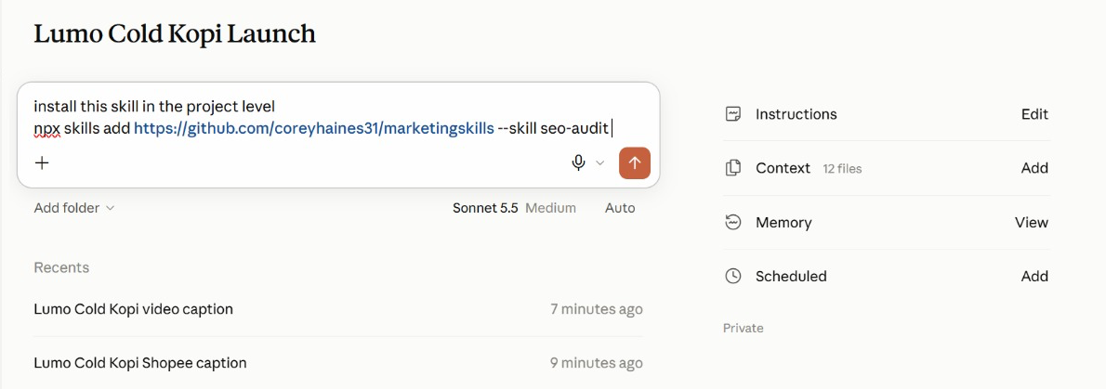
Figure 16 — Install a Published Skill. Ask Claude to install a skill from GitHub into the project.
1. The request — 'Install this skill in the project level', then the npx skills add command.
2. Project level — The skill is available in this project, beside the brand-voice skill you write in Lab 6.
3. Check the source — Read a third-party skill's SKILL.md first — it runs with your access.

Lab 6 — Capture the Brand Voice as an Agent Skill
Objective: By the end of this lab you can capture the brand voice as an Agent Skill with /skill-creator, read its SKILL.md, use it on workplace messages and update it.
Scenario: Every post and customer email has to sound like Lumo. You rewrite five off-brand captions until they are right, save the routine as a lumo-brand-voice skill with /skill-creator and read its SKILL.md. Then you use it on three waiting messages, spot the gap it leaves, and update the skill so every future reply closes it.
You will build: A lumo-brand-voice Agent Skill, read in its SKILL.md, used on three workplace messages, then updated with a customer-reply section and retested.
Tools: Claude Projects, Agent Skills, /skill-creator.
In the project
Part | In this lab
Instructions — HOW | Uses: the never-say-healthy rule becomes a check inside the skill.
Context — WHAT | Uses: the brand guidelines the skill is written from, and the product sheet its replies may quote.
Folder — WHERE | Uses: attach the captions, then the customer messages; the skill saves to Customize → Skills.
Scheduled — WHEN | Not used — runs when you send the prompt.

Lab files
- Prompt PDF: labs/lab-06-brand-voice-skill/lab-06-brand-voice-skill.pdf
- labs/lab-06-brand-voice-skill/data/lumo-sample-captions.txt
- labs/lab-06-brand-voice-skill/data/lumo-customer-messages.txt
Step-by-step
This lab has five blocks, sent at different times. Block 1 does the work once so you can verify it. Block 2 saves it as a skill: type /skill-creator in the composer, then paste the block. Block 3 uses the saved skill on three workplace messages without naming it. Block 4 updates the skill, again after /skill-creator, and Block 5 tests the update in a fresh task.
Note: Blocks 2 and 4 begin with you typing /skill-creator in the composer — it is not part of the pasted text.
1. Open lumo-sample-captions.txt and read the five captions.
Why: Each breaks at least one brand rule — a wrong price format, a health claim, too much slang, too many hashtags.
2. In the project, attach the file and send Block 1.
Why: This is the Do step of Do · Verify · Save · Update. You never write a skill from a blank page.
Block 1 — DO
Attach lumo-sample-captions.txt and send this first, on its own:
PROMPT — copy into Claude
Rewrite the five captions in the attached file in the Lumo
brand voice, following lumo-brand-guidelines.md.

For each caption, show:
- the original
- your rewrite
- every rule you applied, by name
- any claim you removed, and why

Then run these checks on each rewrite and show the result:
price written as S$3.90; no "healthy" or medical claims; at
most one Singlish word; #LumoKopi present; no more than five
hashtags; ends with one clear call to action.

Now stop and read the output. Ask for changes until every rewrite sounds right. Whatever you settle on here is exactly what the skill will reproduce.
3. Check each rewrite against the brand guidelines and refine until all five are right.
Why: This is the Verify step. Ask for changes in plain English; you are teaching the routine by correcting it.
4. Type /skill-creator in the composer, then paste Block 2 and send.
Why: skill-creator writes the SKILL.md from the run you just verified — name, description, instructions and examples.
Block 2 — SAVE
Type /skill-creator in the composer, then paste this:
PROMPT — copy into Claude
Create a skill called lumo-brand-voice from what we just did.

Description: Use when writing or reviewing any customer-facing
Lumo Kopi content - social posts, captions, emails, video
scripts or ads.

It should rewrite or draft content in the Lumo voice, apply the
brand rules, remove claims we cannot prove, and finish with the
same checklist of checks we used. Include two of today's
before-and-after examples as a resource.

Approve the skill when Claude shows it to you, then open Customize → Skills and read its SKILL.md.
5. Read the skill Claude proposes, especially its description, and approve it.
Why: The description is the one part always in context. It decides when the skill loads, so it must say WHEN to use it.
6. Open Customize → Skills, open lumo-brand-voice and read its SKILL.md.
Why: Find the four parts: the name and description at the top, the rules and steps below them, and the examples file beside it. The whole skill is plain text you can read and edit.
7. Start a new task, attach lumo-customer-messages.txt and send Block 3.
Why: Three messages waiting for a reply — the same file for everyone. The prompt does not name the skill, so if it loads, its description did its job.
Block 3 — USE
Start a new task in the project, attach lumo-customer-messages.txt and send:
PROMPT — copy into Claude
Draft replies to messages 1 and 2 in the attached file, and
rewrite the flyer line in message 3 so it is ready to print.

The prompt never names the skill. Check the reply's steps: lumo-brand-voice should have loaded by itself.
8. Check that lumo-brand-voice loaded, then read the flyer line and the café reply.
Why: The flyer line must lose "super healthy" and "best kopi in Singapore" and show S$3.90. The café asks for a wholesale price that is not in the product sheet — the reply must not invent one.
9. Read the reply to message 1 closely.
Why: Does it promise a refund or a new pack? The skill has no rule for customer replies yet. Fix that gap once, in the skill, not in every prompt.
10. Type /skill-creator in the composer, then paste Block 4 and approve the change.
Why: This is the Update step. Claude shows the change and confirms before it replaces the saved skill.
Block 4 — UPDATE
Type /skill-creator in the composer, then paste this:
PROMPT — copy into Claude
Update the lumo-brand-voice skill. Add a section for replies to
customers and stockists:
- thank them, and apologise once if something went wrong;
- never promise a refund, replacement, discount or any price
that is not in lumo-product-sheet.md;
- say the team will reply within two working days;
- sign off "- The Lumo Kopi team".

Show me the change before you save over the skill.

Read the change Claude proposes, then approve it.
11. Start a new task, attach the file again and send Block 5.
Why: A fresh task proves that the updated skill, not the earlier conversation, made the difference.
Block 5 — RETEST
Start a new task, attach lumo-customer-messages.txt again and send:
PROMPT — copy into Claude
Reply to message 1 in the attached file.

The reply should follow the new rules without you repeating any of them.
12. Check the new reply to message 1.
Why: No refund or replacement promised, a reply within two working days, and signed "- The Lumo Kopi team". One edit to the skill now changes every future reply, for you and for anyone who uses it.
Check
You are done when: lumo-brand-voice appears under Customize → Skills, and its SKILL.md shows a name, a description that says when to use it, the brand rules and the checklist. In a fresh task, Block 3 loaded the skill without naming it: the flyer line drops "super healthy" and "best kopi in Singapore" and shows S$3.90, and the café reply does not invent a wholesale price. After Block 4 the skill has a customer-reply section, and the Block 5 reply to message 1 promises no refund, says the team will reply within two working days and signs off "- The Lumo Kopi team".

Skills, plugins and mods
A skill is one routine. A plugin is the whole setup — install the Marketing plugin and you get every skill, command and tool it contains.
 | Skill | Plugin | Mod
Changes | How a task is done | A whole toolkit | Claude's own interface
Contains | One SKILL.md + resources | Skills, tools, agents, hooks | A panel, command, hook or status line
You get it by | Writing it with /skill-creator | Installing from Discover | Asking Claude to make one
Lumo example | lumo-brand-voice | Marketing plugin | A Next Lumo post panel

Mods
- What a mod is — A change to Claude's own interface or behaviour, rather than to the work it does.
- A panel or pane — Something that stays beside the chat and updates — a running checklist, a campaign tracker.
- A status line or toast — A small always-visible signal, such as the active project or remaining usage.
- A slash command — Your own /command that starts a routine you use often.
- A hook — An action that runs automatically on an event — for example, before Claude sends anything.
- Where to find them — Under Customize, alongside Skills, Connectors and Plugins. Ask Claude to make one for you.

Lab 7 — Add the Marketing Plugin and a Mod
Objective: By the end of this lab you can install a plugin, use its namespaced commands alongside your own skill, and build a mod that suggests the next social post.
Scenario: You wrote one skill yourself; now you install a toolkit somebody else packaged. Anthropic's Marketing plugin bundles several marketing skills behind namespaced commands. You install it, use /marketing:campaign-plan to stress-test the launch plan, and run /marketing:brand-review on the deck copy — then compare a plugin with the skill you wrote. Last, you build a mod of your own: a Next Lumo post panel beside the chat that suggests what to post next.
You will build: The Marketing plugin installed, a campaign plan review, a brand review of the launch copy, and a Next Lumo post mod.
Tools: Claude Projects, plugins, mods, Customize.
In the project
Part | In this lab
Instructions — HOW | Uses: plugin commands follow the same project rules.
Context — WHAT | Uses: the brand guidelines, for /marketing:brand-review.
Folder — WHERE | Uses: the research brief, campaign brief and deck; the Next Lumo post mod reads the folder.
Scheduled — WHEN | Not used — the mod suggests a post; nothing runs on a timer.

Lab files
- Prompt PDF: labs/lab-07-marketing-plugin/lab-07-marketing-plugin.pdf
This lab has no data folder — it works from what the project already holds.
Step-by-step
This lab has three blocks. Blocks 1 and 2 are commands from the Marketing plugin: install it first, then send Block 1 and, after reading its answer, Block 2. Block 3 asks Claude to build a mod.
Note: Install the plugin first: Customize → Plugins → Browse, find Marketing, click Install. Then type /marketing in the composer to see its commands.
1. Open Customize → Plugins and browse the available plugins.
Why: Discover before you build: check whether someone has already packaged what you need.
2. Find the Marketing plugin, read what it contains, and click Install.
Why: One install brings several skills and commands at once — the difference between a plugin and a skill.
3. In the project composer, type /marketing and look at the commands it offers.
Why: Plugin commands carry the plugin's name as a prefix. That is how you tell them from a skill you wrote yourself.
4. Open the Marketing plugin in Customize → Plugins, list the skills it contains, and open brand-review.
Why: A plugin skill is the same kind of SKILL.md you wrote in Lab 6 — a name, a description, instructions — packaged with others. Compare its description with yours.
5. Send Block 1 to stress-test the plan with /marketing:campaign-plan.
Why: The plugin's skill works with your project context: the campaign brief and research brief are already there.
Block 1 — PLAN
Send this in the project:
PROMPT — copy into Claude
/marketing:campaign-plan Review the Lumo Cold Kopi launch using
our campaign brief and research brief. Keep our objective,
audience, budget and dates. Tell me:
- what is missing from the plan,
- the three biggest risks to the 1 December launch,
- the KPIs you would track in the first two weeks, with targets.
Do not change the S$60,000 budget.

Read its answer in full before you send Block 2.
6. Read the risks and KPIs it proposes, and check the budget is unchanged at S$60,000.
Why: A plugin is someone else's judgement. Keep what fits your goal; question what does not.
7. Send Block 2 to review the deck copy with /marketing:brand-review.
Why: Two tools on one job: the plugin reviews, and your lumo-brand-voice skill holds the house rules it checks against.
Block 2 — REVIEW
Then send:
PROMPT — copy into Claude
/marketing:brand-review Review the copy on slides 1, 2 and 6 of
our launch deck against lumo-brand-guidelines.md. List each
change you would make and the rule behind it.

Compare its findings with what your lumo-brand-voice skill would flag.
8. Open Customize and look at the Mods section.
Why: Mods change Claude's interface itself — a panel, a status line, a slash command or a hook. You can install one, or ask Claude to make one.
9. Send Block 3 and read what the mod will do before you let Claude install it.
Why: You describe the behaviour in plain English and Claude writes the mod. Check it only suggests — a mod that could post would need your approval rules too.
Block 3 — MOD
Then send:
PROMPT — copy into Claude
Make me a mod: a panel called "Next Lumo post" that stays
beside the chat in this project.

- If social-calendar.csv is in the project, show the next post
due from today: date, platform, format, hook and call to action.
- If there is no calendar yet, suggest one next post instead:
use the top content theme in lumo-research-brief.docx and the
lumo-brand-voice skill, and say which platform and day suit it.
- Add a Refresh button and show when it last updated.
- It only suggests: never post, publish or send anything.

Tell me what the mod will do and where it will appear before
you install it.

Open the Next Lumo post panel and check its suggestion against the brand kit.
10. Open the Next Lumo post panel beside the chat and read its suggestion.
Why: No calendar yet, so it suggests a post from the research brief's top theme. Check the brand voice, S$3.90 and no "healthy". After Lab 8 it shows the calendar's next post.
Check
You are done when: The Marketing plugin is installed and its /marketing: commands appear in the composer. /marketing:campaign-plan returned the gaps, three launch risks and two-week KPIs with targets while keeping the S$60,000 budget and the 1 December date. /marketing:brand-review reviewed the deck copy. You can explain the difference between lumo-brand-voice (a skill you wrote), the Marketing plugin (a packaged bundle) and a mod (a change to Claude's interface). The Next Lumo post panel sits beside the chat and suggests one on-brand post — S$ prices, no health claim — without posting anything.

Topic 03 — Content Production and Scheduled Work
Social posts for four platforms · a launch video · scheduled tasks · the memory file
Key concepts
Concept | What it means
Specs per platform | Instagram, TikTok, LinkedIn and Facebook each get their own spec in the prompt, so one task drafts all four well.
Skill in every task | Every task loads the same brand-voice skill, so four channels still sound like one brand.
Video as code | Claude writes and runs the code that turns a storyboard and your images into an MP4.
Scheduled tasks | A prompt that runs on a timetable — daily, weekly or monthly — inside the project, while you are away.
Approval stays human | A scheduled task drafts and emails the post to you. Publishing is still your click.
A memory file | A Markdown file in the project folder that records decisions, so every later task reads the same facts.

Social content for four platforms
Each platform has its own format, so the Lab 8 prompt gives every platform its own spec:
Platform | Format and rules
Instagram | Carousel or Reel. Hook in the first line; caption up to 2,200 characters; 3–5 hashtags.
TikTok | 9:16 video, 15–30 s. A hook in the first 2 seconds; on-screen text; one call to action.
LinkedIn | Founder or team voice; the story behind the product; no more than 3 hashtags.
Facebook | Community and offers; a clear link to buy; questions that invite comments.

Every post loads lumo-brand-voice, so four formats still sound like one brand.
From brief to calendar
1. Brief once — One prompt: the dates, the four platforms, the spec for each and the skill to use.
2. Draft by platform — Claude works through each platform's posts to its own spec.
3. Check the voice — The brand-voice skill runs its checklist on every post.
4. Save the calendar — The posts land in one dated calendar file in the project folder.
5. Check and approve — You check claims, prices and dates before anything is scheduled.

Lab 8 — Create and Schedule Two Weeks of Social Posts
Objective: By the end of this lab you can produce a two-week, four-platform social calendar using the brand-voice skill, and schedule the daily post.
Scenario: Launch fortnight needs ten posts across Instagram, TikTok, LinkedIn and Facebook. Each platform has its own format, so the prompt gives Claude a spec for each. It loads lumo-brand-voice, drafts every platform's posts to its spec, and saves one dated calendar. Once you have checked it, you create a scheduled task that emails you each day's post at 9:00am as a draft.
You will build: social-calendar.csv with ten dated posts across four platforms, lumo-social-posts.docx with the full copy, and a weekday 9:00am scheduled task that emails each day's post as a draft.
Tools: Claude Projects in Cowork, Agent Skills, scheduled tasks, Gmail connector.
In the project
Part | In this lab
Instructions — HOW | Uses: brand voice, S$ prices, and never publish without your approval.
Context — WHAT | Uses: the brand kit — every post is checked against its prices and claims.
Folder — WHERE | Adds: social-calendar.csv and lumo-social-posts.docx, saved to the folder.
Scheduled — WHEN | NEW: Today's Lumo post, weekdays at 9:00am — emails you each day's post as a draft.

Lab files
- Prompt PDF: labs/lab-08-social-posts/lab-08-social-posts.pdf
- labs/lab-08-social-posts/data/social-calendar-template.csv
Step-by-step
This lab has two blocks. Block 1 creates the calendar. Block 2 is pasted into the Create scheduled task dialog, once you have checked the calendar.
Note: Attach social-calendar-template.csv from the Lab 08 data folder. Replace <YOUR EMAIL> in Block 2.
1. In the project, attach social-calendar-template.csv and send the lab prompt.
Why: One task with four precise specs. In the Threads edition each platform gets its own thread; here the specs keep one task on track.
Block 1 — CREATE
Start a new task in the project and send:
PROMPT — copy into Claude
Create the launch social calendar for Lumo Cold Kopi: ten posts,
one each weekday from Tuesday 1 December to Monday 14 December
2026, using social-calendar-template.csv for the columns.

Draft each platform's posts to its own spec:
- Instagram: 3 posts (carousel or Reel), caption with a hook in
the first line, 3-5 hashtags.
- TikTok: 3 posts, each a 15-second video script with a hook in
the first 2 seconds and on-screen text.
- LinkedIn: 2 posts in the founder's voice, the story behind the
product, no more than 3 hashtags.
- Facebook: 2 posts for community and the 12-pack offer.

Use the lumo-brand-voice skill for every post, and our top
content theme from the research. The 1 December launch-day
post is an Instagram Reel; TikTok follows on 2 December.

Then save them into social-calendar.csv (date, platform,
format, hook, copy, hashtags, visual idea, call to action) and
lumo-social-posts.docx with the full copy. Report the brand-voice
checklist result for every post, and list any post that failed.

Check the calendar in the next steps before you schedule anything.
2. Watch Claude work through the four platforms.
Why: Each platform is drafted against its own spec, so the TikTok scripts and the LinkedIn story stay distinct.
3. Check in the task's activity that Claude loaded lumo-brand-voice.
Why: The skill you wrote in Lab 6 is now doing its real job: keeping four formats in one voice.
4. When the calendar arrives, count the rows and check the dates.
Why: Ten rows, weekdays only: 1, 2, 3, 4, 7, 8, 9, 10, 11 and 14 December. Instagram 3, TikTok 3, LinkedIn 2, Facebook 2.
5. Read the brand-voice checklist results.
Why: Every post should pass. If one fails, ask Claude to redraft it.
6. Spot-check three posts against the campaign brief's "claims we must not make".
Why: Parallel production is fast; a human check on the claims is what makes it safe to publish.
7. Open lumo-social-posts.docx and confirm the copy matches the calendar.
Why: The calendar is what the scheduled task you create next reads every morning.
8. Open Scheduled tasks from the sidebar (or the project's Scheduled panel), choose New task, then Set up manually.
Why: Create with Claude asks you questions instead; setting it up manually shows you every field.
Block 2 — SCHEDULE
Paste into the Instructions field of a new scheduled task named "Today's Lumo post":
PROMPT — copy into Claude
Take today's row from social-calendar.csv in the project folder,
polish the post with lumo-brand-voice, and check every price and
claim against the brand kit. Email it to <YOUR EMAIL> as a draft
with the subject "Today's Lumo post - <date>".

Never publish anything and never post to social media. If there
is no row for today, email "No Lumo post scheduled today".

Pick the Lumo Cold Kopi Launch project, set Frequency to weekdays at 9:00am, and save. Permissions defaults to *Automatically approve* — which is why the task only drafts.
9. Name it Today's Lumo post and paste Block 2 into Instructions, with your own email.
Why: The task runs in the project, so it inherits the instructions, context, folder and the brand-voice skill — the prompt stays short.
10. Pick the Lumo Cold Kopi Launch project, set Frequency to weekdays at 9:00am, check Permissions, and save.
Why: Frequency defaults to Manual — a task left on Manual never runs. Permissions defaults to Automatically approve, so the task must only draft.
11. Confirm the task appears under Scheduled with the right days and time, and use Run now if it is offered. Then open the Next Lumo post panel from Lab 7 and click Refresh.
Why: A test run's email shows exactly what arrives each morning. The panel now reads the calendar and shows the 1 December post.
Check
You are done when: social-calendar.csv has ten rows dated on the ten weekdays from 1 to 14 December 2026 — Instagram 3, TikTok 3, LinkedIn 2, Facebook 2 — with the 1 December launch post an Instagram Reel and TikTok on 2 December. Every post passed the lumo-brand-voice checklist, none uses "healthy", every price is written S$3.90 or S$42.00, and lumo-social-posts.docx carries the same copy. Today's Lumo post is listed under Scheduled for weekdays at 9:00am; it drafts and emails only, and nothing was published.

From the class
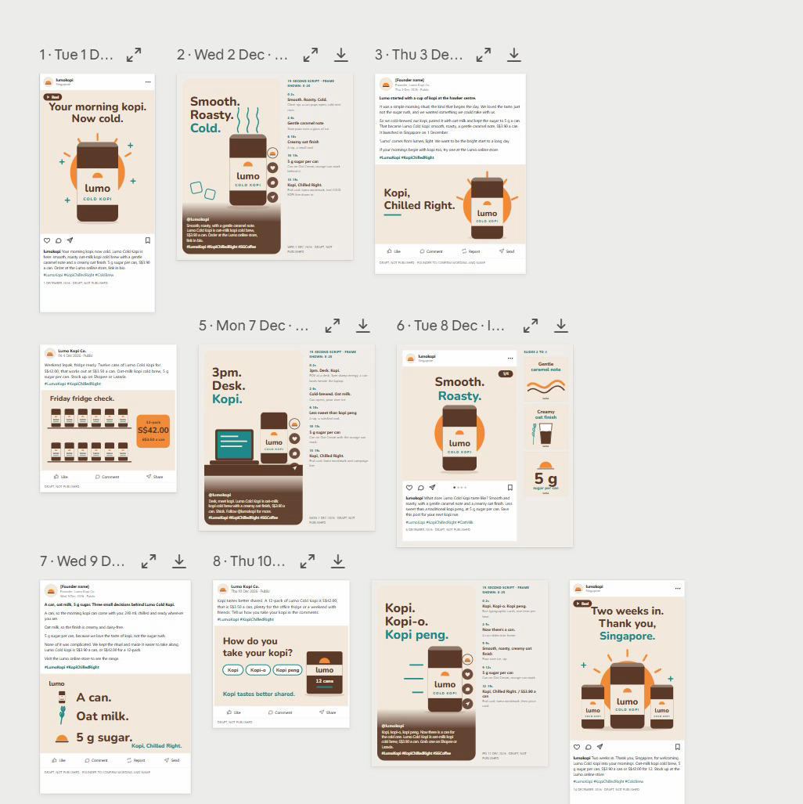
Figure 17 — From the Class: Two Weeks of Posts. The Lab 8 posts laid out by date — every one a draft, not published.
1. One calendar — Dated posts from 1 to 14 December across the four platforms.
2. One voice — The brand-voice skill keeps every hook and caption consistent.
3. Review — Expand or download any post; each is marked DRAFT, NOT PUBLISHED.

The video pipeline
Claude does not edit video by hand — it writes and runs the code that renders it. The work runs in five stages:
1. Script — Five lines, three seconds each — hook, problem, product, proof, call to action.
2. Storyboard — One frame per line: which image, which on-screen text, which motion.
3. Render — Claude writes and runs code that animates your images and text into an MP4.
4. Check — Length, size 1080 × 1920, brand colours, every claim true, end card with the price.
5. Refine — Ask for timing or text changes in plain English and render again.
Video specifications
Spec | Requirement
Format | Vertical 9:16, 1080 × 1920 pixels, MP4 — fits Reels, TikTok and Shorts.
Length | 15 seconds: five scenes of three seconds each.
Text | Large, high-contrast captions — most people watch with the sound off.
Brand | Lumo colours and logo; the end card shows the price and the campaign hashtag.
Assets | Only the supplied product images — never a real person's likeness or a stock logo.
Fallback | No video tools in the session? Claude builds an animated HTML version to screen-record.

Lab 9 — Produce a 15-Second Launch Video
Objective: By the end of this lab you can script, storyboard and render a vertical launch video from supplied brand assets.
Scenario: The TikTok and Instagram posts need a launch video. You give the project the supplied product images and logo; Claude first writes a five-scene script and storyboard with lumo-brand-voice, then writes and runs the code that animates the images and captions into a 15-second, 1080 × 1920 MP4. You check it frame by frame and ask for changes in plain English.
You will build: lumo-launch-15s.mp4 (1080 × 1920, 15 seconds), with its script and storyboard.
Tools: Claude Projects in Cowork, code execution.
In the project
Part | In this lab
Instructions — HOW | Uses: brand voice for the script; nothing is published.
Context — WHAT | Uses: the brand kit, for the tagline, price and call to action.
Folder — WHERE | Adds: attach the video assets; the script, storyboard and lumo-launch-15s.mp4 are saved here.
Scheduled — WHEN | Not used — runs when you send the prompt.

Lab files
- Prompt PDF: labs/lab-09-launch-video/lab-09-launch-video.pdf
- labs/lab-09-launch-video/data/video-assets/lumo-can.png
- labs/lab-09-launch-video/data/video-assets/lumo-12pack.png
- labs/lab-09-launch-video/data/video-assets/lumo-logo.png
- labs/lab-09-launch-video/data/video-assets/scene-hawker.png
- labs/lab-09-launch-video/data/video-assets/scene-office.png
Step-by-step
1. Open the Lab 09 data/video-assets folder and look at the five images.
Why: These are the only images the video may use. Supplying assets is how you keep likenesses and logos safe.
2. In the project, attach the folder and send the lab prompt.
Why: Two stages in one task: the render waits for the script, so you can read the storyboard first.
PROMPT — copy into Claude
Make a 15-second vertical launch video for Lumo Cold Kopi, using
only the five images in the attached video-assets folder.

Work in two stages:
Stage 1 - SCRIPT: with lumo-brand-voice, write five scenes of
three seconds each: hook, problem, product, proof, call to action.
For each scene give the image, the on-screen text (max 6 words)
and the motion. Save it as lumo-video-storyboard.md.
Stage 2 - RENDER: when the storyboard is ready, write and run
code that renders it to lumo-launch-15s.mp4: 1080 x 1920, 30 fps,
exactly 15 seconds, large high-contrast captions in the Lumo
colours, a gentle zoom on each image, and an end card with the
logo, "From S$3.90" and #KopiChilledRight.

If you cannot render video in this session, build the same thing
as an animated HTML page at 1080 x 1920 and tell me, so I can
screen-record it. Report the file's duration and size when done.

Note: Attach the whole video-assets folder. Use only the supplied images — never a real person's likeness or another brand's logo.
3. Read the storyboard when Stage 1 finishes.
Why: Five scenes, three seconds each, captions of six words or fewer, and no health claims — the brand-voice skill applies to scripts too.
4. When the video arrives, check the reported duration and size.
Why: Exactly 15 seconds and 1080 × 1920. A wrong size is the most common reason a platform crops your captions.
5. Play it through, then scrub it frame by frame.
Why: Check every caption is readable with the sound off and the end card shows the logo, From S$3.90 and #KopiChilledRight.
6. Ask for one change, for example: Hold the end card for one second longer and shorten scene 2.
Why: The video is code, so a change is a re-render, not a re-edit. Check the length is still 15 seconds afterwards.
7. If Claude built the HTML fallback instead, open it full screen and screen-record 15 seconds.
Why: Same storyboard, different renderer. The checks stay the same.
Check
You are done when: lumo-launch-15s.mp4 is 1080 × 1920, 30 fps and 15 seconds long, uses only the supplied images, shows five scenes with captions of six words or fewer in the Lumo colours, and ends on a card with the logo, "From S$3.90" and #KopiChilledRight. lumo-video-storyboard.md sits beside it and matches what plays. No scene makes a health claim.

Scheduled tasks
A scheduled task has six parts. Write each one down before you schedule anything:
Part | What to decide
Name | What the task is called in the Scheduled list — for example, Today's Lumo post.
Instructions | Exactly what to do each run — written like a lab prompt, with the checks included.
Project | Pick the Lumo Cold Kopi Launch project, so the task reads its instructions, context and folder.
Frequency | Daily, weekdays, weekly or monthly. The default is Manual — change it.
Permissions | Defaults to Automatically approve: the task acts unattended, so it must only draft.
Require this computer | On: runs only while your computer is awake, with your folders. Off: runs without them.

Examples for the launch
Schedule | Task
Daily post, weekdays 9:00am | Take today's row from the social calendar, polish it with lumo-brand-voice and email it to me for approval.
Weekly report, Mondays 8:00am | Summarise last week's posts from the social calendar and anything new in the Lumo Launch Drive folder in five bullet points.
Monthly scan, 1st at 10:00am | Check the six competitors for new products or price changes and update the research brief.

Open Scheduled tasks from the sidebar (or the project's Scheduled panel), choose New task and Set up manually. A task with Permissions on Automatically approve must only draft.
Responsible marketing with Claude
Speed is only useful if what goes out is true and fair. Keep these rules on every job:
Rule | In practice
Claims you can prove | “5 g sugar” is on the label. “Healthy” is a claim Lumo cannot substantiate — never use it.
Consent for email | Email only people who opted in. Lab emails go to yourself, never to real customers.
No real likenesses | Do not generate a real person, influencer or competitor logo into an ad.
Disclose partnerships | Influencer posts are labelled as paid partnerships.
A human publishes | Claude drafts and schedules drafts; a person approves every public post.
Keep the source | Keep the research files, so every number in a post can be traced back.

Lab 10 — Schedule the Weekly Report and Review the Project
Objective: By the end of this lab you can schedule a weekly report beside the daily post, keep the project memory file current and review the project.
Scenario: Lab 8 scheduled the daily post. The launch also needs a report every Monday, and nobody should have to remember it. You create it as a second scheduled task on the project, then do the housekeeping a real project needs: record a changed plan in the memory file, and review what the project now holds.
You will build: A weekly-report scheduled task beside Lab 8's daily post, an updated memory file and a project review.
Tools: Claude Projects in Cowork, scheduled tasks, Gmail connector.
In the project
Part | In this lab
Instructions — HOW | Reviews: which instructions are now out of date.
Context — WHAT | Reviews: which context files the launch-date change affects.
Folder — WHERE | Updates: lumo-project-memory.md records the 8 December Singapore launch.
Scheduled — WHEN | NEW: Weekly launch report, Mondays at 8:00am — beside Lab 8's daily post.

Lab files
- Prompt PDF: labs/lab-10-schedule-and-review/lab-10-schedule-and-review.pdf
This lab has no data folder — it works from what the project already holds.
Step-by-step
This lab has three blocks. Block 1 is pasted into the Instructions field of the Create scheduled task dialog, not typed into the chat. Block 2 updates the project's memory file. Block 3 asks the project to review itself.
Note: Replace <YOUR EMAIL> in Block 1. Copy social-calendar.csv from Lab 8 into the project folder if Claude saved it elsewhere.
1. Open Scheduled tasks from the sidebar (or the project's Scheduled panel), choose New task, then Set up manually.
Why: You did this in Lab 8 for the daily post; this time the timetable is weekly.
2. Name it Weekly launch report and paste Block 1 into Instructions, with your own email.
Why: The task runs in the project, so it inherits the instructions, context and folder — the prompt stays short.
Block 1 — WEEKLY REPORT TASK
Paste into the Instructions field of a new scheduled task named "Weekly launch report":
PROMPT — copy into Claude
Summarise last week's posts from social-calendar.csv and anything
new in the Lumo Launch Drive folder in five bullet points, and
email the summary to <YOUR EMAIL>. Draft only - do not send
anything else.

Pick the project, set Frequency to weekly, Mondays at 8:00am, and save.
3. Pick the Lumo Cold Kopi Launch project, set Frequency to weekly, Mondays at 8:00am, and save.
Why: Frequency defaults to Manual — a task left on Manual never runs.
4. Confirm both tasks appear under Scheduled: Today's Lumo post and Weekly launch report.
Why: Two tasks, two timetables, one project. This is where you would add a monthly competitor scan next.
5. Start a new task in the project and send Block 2.
Why: Expect the calendar, Today's Lumo post, the deck's title slide and timeline, and the brief. The memory file is how one fact reaches every later task.
Block 2 — MEMORY
Start a new task in the project and send:
PROMPT — copy into Claude
Add this to lumo-project-memory.md: the Singapore launch has
moved from 1 December to 8 December 2026. Kuala Lumpur is
unchanged. Then tell me everything in the project folder and
scheduled tasks that depends on the launch date - posts, tasks,
the deck, the brief - and propose the changes. Do not make them yet.

Open lumo-project-memory.md in the folder and check the new line.
6. Open lumo-project-memory.md and check the new launch-date line. Edit it if the wording is wrong.
Why: Claude writes the file, but you own it. Delete anything you would not want every future task to believe.
7. Send Block 3 at the end of the lab.
Why: A project that can list its own files and what each is for is one a colleague can pick up tomorrow.
Block 3 — REVIEW
Send this at the end of the lab:
PROMPT — copy into Claude
Review this project for me: list every file in the project
folder, which lab produced it, and what it is for. Then tell me
which instructions, context files or memory-file lines are now
out of date.

Compare its list with the folder on your computer.
8. Open Settings → Usage and see how much of your plan today's labs used.
Why: Parallel tasks finish faster but use more in total — worth knowing before you schedule work every day.
Check
You are done when: Two scheduled tasks are listed on the project — Today's Lumo post from Lab 8 on weekdays at 9:00am and Weekly launch report on Mondays at 8:00am — both drafting and emailing only, with nothing published. lumo-project-memory.md records the 8 December Singapore launch, Claude listed what depends on it, and the project review matches the files in your Lumo Launch folder.

Wrap-Up
Across ten labs you took one product launch from an empty project to a researched, branded and scheduled campaign.
What you built
- The Lumo Cold Kopi Launch project, with instructions, context, a folder and a memory file.
- A market research brief merged from four parallel tasks, with conflicts flagged.
- A Market Insights Live Artefact dashboard, saved and downloaded.
- Google Drive and Gmail connected, with an approved summary sent to yourself.
- A launch deck in Slides and a campaign brief in Docs.
- A lumo-brand-voice Agent Skill and the Marketing plugin.
- Two weeks of social posts across four platforms.
- A 15-second vertical launch video.
- Scheduled tasks that draft the daily post and the weekly report for your approval.
The habit to keep
- Give long-running work a project with clear instructions, not a string of chats.
- Split big jobs into focused tasks, one subject each, and merge the results.
- Check every figure and claim against the source before anything goes out.
- Write a routine down once as a skill instead of retyping it every time.
- Schedule the drafting; keep the publishing click for yourself.
Next steps
- Start one real Project — Give your next campaign a project with instructions, context and a folder.
- Split one job into tasks — Next time you research competitors, give each one its own task.
- Capture your brand voice — Turn your real brand guide into a skill your whole team shares.
- Analyse one dataset — Attach a real export, define your terms, and check the code and the totals.
- Schedule one routine — Pick the post or report you produce every week and schedule the draft.
- Watch for the new Projects — When your account gets the lead agent and threads, the Threads edition of this course shows the same labs on it.

Glossary
Term | Meaning
Agent Skill | A folder containing a SKILL.md of instructions that Claude loads on demand when the task matches its description.
Artefact | A self-contained output Claude builds — a document, dashboard or tool — shown beside the chat rather than inside it.
Claude Project | A workspace for one long-running body of work, with its own instructions, context files, working folder and scheduled tasks.
Code execution | Claude's built-in tool for writing and running code on your files — how it analyses data, draws charts and builds files.
Connector | An integration that lets Claude reach an outside service such as Google Drive, Gmail or Calendar.
Context | Reference material a project reads but never edits — files, a folder, a Google Drive folder or a GitHub repository.
Instructions | Standing rules you write once that every session in a project follows — how Claude must behave.
Live Artefact | An artefact that persists in your workspace, keeps its state, and can refresh its data when reopened.
MCP | Model Context Protocol — the open standard connectors use to expose tools and data to Claude.
Memory | What a project keeps between tasks. In a classic project, the memory file you ask Claude to maintain; in the new Projects, editable memory in settings.
Memory file | A Markdown file in the project folder where Claude records decisions you ask it to keep, read by every later task.
Mod | A change to Claude's own interface or behaviour, such as a side panel, status line, slash command or hook.
Plugin | A packaged bundle of skills, tools, agents and hooks, installed in one step.
Project folder | The folder on your computer a Cowork project works in: Claude reads data there and writes its outputs back.
SKILL.md | The Markdown file at the heart of an Agent Skill: name, description and instructions.
Scheduled task | A prompt a project runs automatically on a timetable.
Session | One conversation with Claude, with its own context window. A project holds many sessions.
Task | One job you start inside a project. Several tasks can run at once.
Tool | One action Claude can take — search, read, run code, create a file, send. Built in, or added by a connector.
Tool call | One use of a tool, shown as a step in Claude's reply with its input and its result.

